Journey to the Heart of the Lotus

Unlearning “Buddhist” Meditation

Authors (each one on new line)

brahm

Item Type:

book

Short Abstract:

Based on talks given by Ajahn Brahm during a recent retreat at Jhana Grove Meditation Centre, this book records with gratitude his easy-to-follow step-by-step guide to meditation as laid out by him over the retreat.

Reflecting Ajahn Brahm’s unique way of teaching, the image of the lotus gradually unfolding is used as he shows us, chapter by chapter, how we too can discover the joy and happiness of meditation as taught by the Buddha.

Abstract:

None

Copyright:

First published in 2024 by Wisdom & Wonders Books.  
This second edition published in 2025.  
The author Ajahn Brahm has waived all copyright and related or neighbouring rights to Journey to the Heart of the Lotus and dedicates it to the public domain.  
Three Questions: Taken from the collection *‘What Men Live By, and Other Tales’* by Leo Tolstoy, as translated by Louise Maude and Aylmer Maude. This work is in the public domain.  
Find more information on Ajahn Brahm at [bswa.org](https://bswa.org/)   
Watch a video about the monastery where Ajahn Brahm resides at [youtu.be/GOL5RTd-Wdk](https://youtu.be/GOL5RTd-WDk)   
This is book is offered for free. Please do not sell this book.  
Also available to read online and for free download from [wiswo.org/books/journey](https://wiswo.org/books/journey)   
CC0 1.0

Downloads:

pdf=yes  
epub=yes  
azw3=yes

Backcover:

Discover the magic of kindfulness with Journey to the Heart of the Lotus, a guide to peace and insight based on the teachings of Ajahn Brahm on his 2023 Easter retreat at Jhana Grove.

Each chapter will take you deeper into the art of letting go, calming the mind and embracing the present moment.

Whether you're a seasoned meditator or just beginning your practice, a path to the radiant joy of stillness and true serenity awaits you within these pages.

Special Message

We will welcome anyone who would like to sponsor a print run of the book for distribution around monasteries and Buddhist centres, as well as at retreats. Message [@dheerayupa](https://discourse.suttacentral.net/u/dheerayupa/summary) or [@stu](https://discourse.suttacentral.net/u/stu/summary) on the SuttaCentral Forum.

5



“The Buddha taught the eightfold path   
because you need all eight parts.   
There is no shortcut. Every part is important.   
This means you can’t get enlightened just by being mindful.   
You need to keep precepts,   
you need to have Right View,   
and you also need jhāna, the eighth factor of the path.”

Ajahn Brahm

Foreword

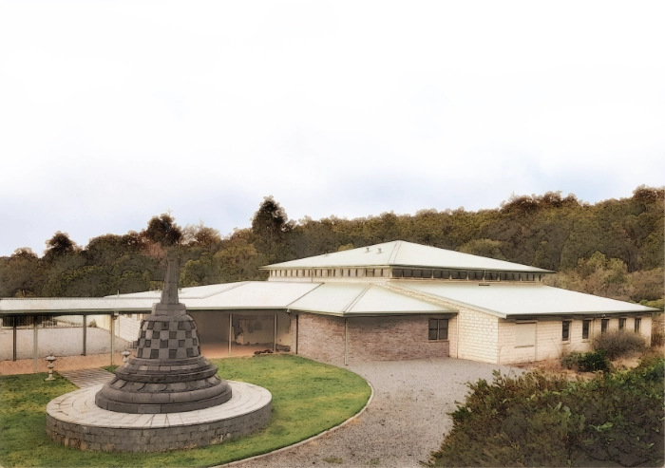

Ajahn Brahm is a beloved spiritual teacher who has inspired millions of people on several continents. While his infectiously happy smile brings warmth and joy, even to people in distress, his teachings shed light on how to find the path to the ultimate happiness.

One of Ajahn Brahm’s great visions is to create a place for lay people to practise meditation. The first one is Jhana Grove in Serpentine, south of Perth, Western Australia.

*Journey to the Heart of the Lotus* is inspired by and based on the talks given by Ajahn Brahm during the 2023 Easter retreat at Jhana Grove and is an easy-to-follow step-by-step guide to meditation and beyond.

Jhana Grove has seen a great number of retreatants enjoying Ajahn Brahm’s teachings, discovering the happiness of meditation and leaving the retreat with a heart inspired, a mind more settled in peace, and a straightforward guide to walking the path as laid out by the Buddha.

This book has been lovingly compiled and organised by the Wisdom & Wonders Book Project team with Ajahn Brahm’s permission to celebrate the 50th anniversary of his ordination as a monk. Any errors are ours, and ours alone. We sincerely welcome all feedback to improve the book.

2

You yourselves must do the work,   
the Realised Ones just show the way.

Dhammapada  
[Dhp 276](https://suttacentral.net/dhp276/en/sujato)

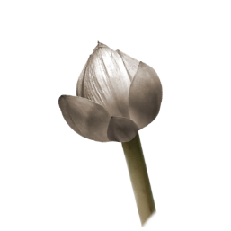

1. Get Set

Difficult it is to gain a human birth;   
Difficult is the life of mortals;   
Difficult is the chance to hear the true Dhamma;   
Difficult is the arising of Buddhas.

Dhammapada  
[Dhp 182](https://suttacentral.net/dhp182/en/sujato)

A Taste of Happiness



I first practised meditation over fifty years ago. I still remember the place. It was in the Wordsworth Room of King’s College in Cambridge.

The meditation was only about ten minutes long, but I still remember the amazing feeling I had the first time I closed my eyes and followed the instructions. I loved to relax and be happy, calm, and peaceful without anything to stimulate me. Experiencing that, I became addicted to meditation straight away.

Not every meditation session will be peaceful, but many will. I’ve said many times that pleasure and delight are important parts of what meditation is and how it develops. In meditation you learn to be happier and happier.

People often ask me what to do to get good meditation.

The answer is simple—Nothing.

Here is a glass of water.

How do I keep this water perfectly still?  
No matter how hard I try, it keeps moving!   
Maybe I need to be more mindful?

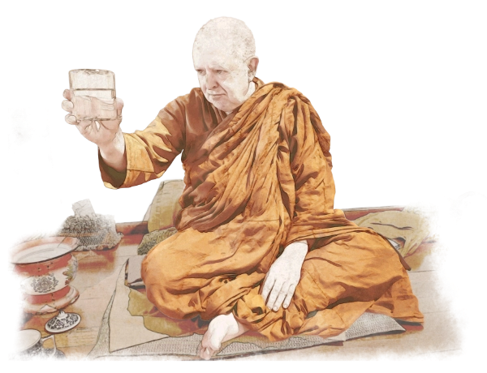

Many of you have been meditating like this for years, and you think you can’t do it. But there is an easy way to keep the water perfectly still for as long as you want. It’s very simple.

Put the glass down.

Let the mind become peaceful by itself.  
This is called  
‘Right Effort’.

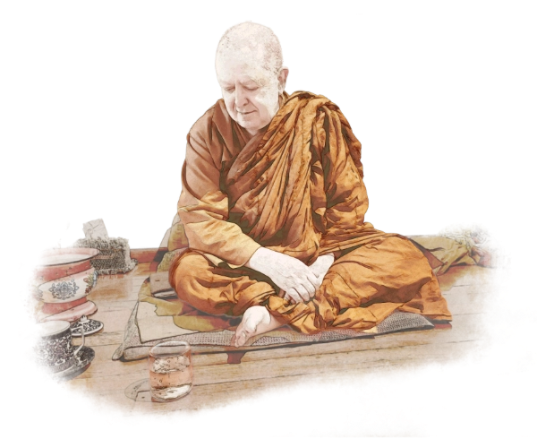

By understanding that *the goal of meditation is stillness*, we can learn how to meditate and cultivate calmness and happiness. A still mind is a joyful mind.

Leave it Alone

We are chronic doers. Our mind is often agitated, always moving around, always thinking of this and that. It’s very hard for us to leave things alone, especially when we’re watching something.

It’s almost like we’re a back-seat driver. Even though the person driving the car may be a good driver who knows which way to go, we may find ourselves saying, “Go left … That’s much better … Put your foot down, I’m in a rush!”

It’s very hard just to watch what’s going on without interfering. Instead, we tend to get involved. We think we’re helping, but we’re actually disturbing the ride.

If we just let go and leave things be, the mind becomes peaceful all by itself. The less you do, the more peaceful you are. From this peace, you get energy with joy naturally arising in the mind.

During my final examinations as a theoretical physics student at Cambridge, I had to do a three-hour paper in the morning and a three-hour paper in the afternoon, six days in a row. After the morning session, instead of taking lunch, I would walk back to my room, sit on a cushion, meditate for half an hour, and then walk back to the hall for the afternoon exam.

When I sat down to meditate, the first thing that came into my mind was the thought of how I had done in the morning exam. It was illogical, because regardless of how I had done, I couldn’t change anything. The paper had already been submitted.

So, I let go of the past. But as soon as I let go of the past, the future entered my mind: the afternoon exam I was having in half an hour!

I then thought that maybe I should get up and do some last-minute revision and not waste time meditating. Yet I knew that what was important was to prepare my mind and body for the next exam. I needed to rest, not work. So, I let go of concerns about the future.

What came next surprised me.

When I stopped thinking of the past and the future and became aware of my body, I noticed that my body was shaking. I had never considered myself a nervous person, and because I’d only been thinking about the exams, I hadn’t been aware of my body. That awareness gave me feedback on what to do. It was then very simple to calm down my body and relax. Soon I became still and peaceful.

The next thing I noticed was how tired my mind was. But when I stayed in the present, my mind gained a huge amount of energy. Once that happened, my mind became clear and recharged.

With a spring in my step, I walked into the afternoon exam with a big grin on my face. Later, my classmates told me I was the only student who was smiling as I came into the exam room. They all thought I was cheating!

This experience taught me not just how to succeed in life but also how to find joy and energise myself.

Letting go works.

The Emperor’s Three Questions

My job as a teacher is to make you trust the process so that you don’t keep interfering with it.

At the beginning of meditation, sit down, get your body nice and comfortable, establish enough mindfulness by watching what’s going on without interfering, and see what’s happening right now. That’s enough to begin.

If you want more instructions, you can consider the emperor’s three questions, which simplifies the idea of meditation beautifully. It comes from a story by Leo Tolstoy called the Emperor’s Three Questions.[1] In this story, an emperor thought that he would never meet with failure if only he knew the answers to the three important questions. I’ve reworded the questions a little. Here they are:

* When is the most important time?
* Who is the most important person?
* What is the most important thing to do?

When is the most important time? The most important time is always right now. It is the only time you really have and the only time you can do anything. Your future is being made by the quality of your attention in the present. So if you care about your future, put your attention in the present.

Who is the most important person? When I read this story as a student, I always thought the most important person would be some big shot, like the pope or the Buddha. That wasn’t the right answer at all. Then, I thought, “Ah, it’s me!” I thought I should look after myself! Both answers are wrong. The right answer is powerful, and it has changed much of the way I look at life. The most important person is whoever is right in front of you.

What is the most important thing to do? The answer is to care. If you come and talk to me, I'll give you my full attention. That way we can actually communicate. When we care, we’re being mindful and compassionate.

Those are the emperor’s three questions. So, what’s that got to do with meditation? Well, when you sit down for meditation, close your eyes and ask yourself:

* When is the most important time?  
  *Now.*
* What’s the most important thing?  
  *It’s what’s in front of you right now: your mind.*
* What’s the most important thing to do?   
  *To care for it.*

Open the door of your heart to this moment, no matter what it is. Then you’ll find that your mind won’t wander, and there’s no way you can be restless. If you care for this moment, the mind will open up to you. As your mindfulness increases in strength, you’ll see that striving isn’t necessary. You can see much more, and your experience becomes so joyful.

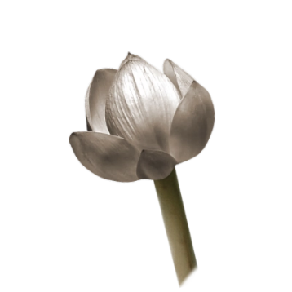

2. Ready, Steady, Stop!

Respect and humility,  
contentment and gratitude,  
and timely listening to the Dhamma:  
this is the highest blessing.

Maṅgalasutta  
[Snp 2.4:9.1–9.4](https://suttacentral.net/snp2.4/en/sujato#9.1)

With a Laugh and a Smile

It’s useful to have humour in our spiritual life.

What does laughter do to you? It gives you energy, relaxes your body, and it’s excellent for your respiratory system, but most of all it takes away the seriousness with which people approach their spiritual practice.

Laughter actually helps and supports our meditation. People who are overly serious might appear composed, but that’s only on the outside. Controlling and holding things tight, they never get into deep meditation.

During my first year as a schoolteacher at a grammar school, I had to give a spiritual teaching to hundreds of children at a morning assembly for five mornings straight. I went to the principal and asked if I could teach meditation to the children. He said yes.

I told the students that we were going to do a bit of meditation for five minutes. I asked them to sit cross-legged on the floor, with their back straight and their right hand over their left hand, and then to close their eyes. I guided them through some breath meditation. They all went for it, with not a single child either giggling or complaining. Once I had finished, they erupted in applause, with laughter and big smiles on their faces! Somehow, I’d touched something in their hearts.

Many years later, a gentleman came up to me and asked if I remembered him. He was one of the children that I’d taught meditation to. It had changed his life.

If you keep things strict, people get stressed out. They get tight in the body and tense in the mind. People get more work done when they’re happy and in a good mood. If a person is motivated, the quality and the quantity of their work increases.

The same principle applies in meditation. Even though you really want to meditate, if you do it without happy thoughts or feelings, your meditation never really goes deep.

Don’t Fight the Demons

An important question that people often ask me is: “My mind is always wandering around all over the place. What should I do?”

When I was a young meditator, I was taught to ‘just bring it back’. However, I tried it for four or five years and it didn’t work! So, I started to investigate it for myself.

What I discovered is that it is the way we treat our mind that makes it wander.

When I was about thirty years old, I was in the north of Thailand in a beautiful monastery. I was all by myself with nothing to do. After a while my mind became restless, and the restlessness soon turned into sexual thoughts. I was embarrassed and ashamed of these thoughts, and so I’d tell myself, “Come on, go back to the breathing.” Yet the harder I tried, the stronger those fantasies became. It was driving me crazy. I was living there by myself with no one to talk to, and I couldn’t tell the lay people for fear they’d chase me out!

So, what did I do? In desperation, I went to the Buddha statue, bowed three times, and asked for help. Then, an idea came to me: “I’ll make a deal!” The deal was that from three to four p.m. each day, I would allow my mind to think of anything it wanted. All I asked for in return was that for the rest of the day, I’d be left in peace. That felt like a fair deal to me.

What happened really blew me away, and it taught me a lot about how the mind works.

The next day my mind was still battling with lustful thoughts throughout the day. When three p.m. was approaching. I went to my hut, leant against the wall, and said to my mind, “OK, now is the time. Think anything you like!”

Do you know what happened? For the next hour I was aware of every single breath without missing one!

It taught me that fighting the demons made them stronger. When I let go, the breath was there, waiting for me.

So we should begin our meditation by making friends with our breath.

But often we forget this. Imagine I said to you, “You’d better watch your breath, or you’ll be in big trouble!” Because I was acting like a control freak, you’d either get tense, scared, or rebellious.

No one likes a control freak. Our mind wanders off because we haven’t got a good relationship with it. We say: “Right, mind! We’re just watching the breath. Nothing else!”

If somebody treats you like that, you want to run away. But when you have a good attitude towards your mind, when you are kind to it, the mind feels almost excited. “Yeah! We’re meditating again! Let’s go for it.”

Now is the only time you’ll ever have in this world. The most important meditation object is what you’re experiencing right in this moment. So, be kind to it.

Don’t Try to Be Perfect

At the start of meditation, the body can be tricky to deal with because of aches and pains. But if I send kindness to it, the body soon relaxes. After five or ten minutes, my body is like, ‘Wow, there’s no ache or pain anywhere.’ If we let the body be, the body balances itself out.

Sometimes you may feel hot spots in your body. People sometimes come to me in meditation interviews and ask what they are. When that happens, I always smile and say, “Well done.”

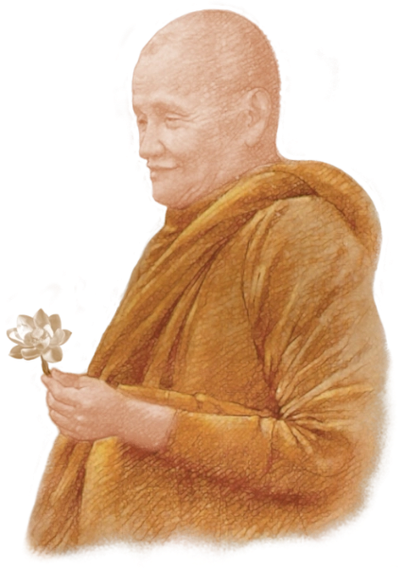

When Ajahn Chah[2] was growing up as a monk, there was a lot of malaria in the jungle, and he would often get sick from it. When his body was weak, Ajahn Chah would come down with a fever. One time in his meditation, he decided to direct his mind to go inside the body to where he felt was the hottest, to where the fever was raging. Even though the forest around him was cool, he felt like he was sitting in the middle of a forest fire. Interestingly, where he was sitting in the middle of this rampant fire, in a calm place of awareness, it was cool. He allowed the heat he felt enveloping him to get so hot that eventually it erupted and exploded.

Bang!

That was the end of his fever. After that, he never got malaria again. That’s the kind of thing that happens when we use our mind wisely.

You could have an incipient cancer in your body. If you relax the body and just let it be, the energy of the body would go to that spot and might be able to heal it. If we just leave things alone, the body may heal all by itself. After all these years of practising, I’ve got incredible faith in the body’s ability to heal itself. We just need to get out of the way and let it happen.

When I first started meditating, sometimes my body would slump before it straightened up again. I knew I’d done nothing. I never told my body to straighten up; it did it all by itself. I love those experiences when you’re perfectly mindful and the body just straightens up by itself. It made me start to trust my body. My body knew exactly what to do, and I could just leave it alone and just watch it happen, almost as if it weren’t my body.

You don’t have to keep fixing your body, just leave it alone and let it settle in. Once it starts to settle, even that much is joyful. Your body will be at ease, which is an important part of any kind of meditation.

The Soft Rock

When I was a young monk in the north-east of Thailand, I suffered from tiredness and lethargy. I would fight and struggle with it, but after five or ten minutes, I tended to fall asleep.

When I went to Bangkok to renew my visa, I stayed at a temple which had an air-conditioned room. It was like going to heaven! At Ajahn Chah’s monastery, we had to get up at three in the morning, but when we were in Bangkok, we got up at four. Having that extra hour of sleep made me more energised and awake. With an air-conditioned room to meditate in during the early morning before alms round, I had no problem at all with my meditation. The tiredness just wasn’t there. It was a physical problem, that’s all. Once you have physical comfort, it’s much easier to be mindful.

Another time when I went to visit our monastery in the UK for the first time, I felt very tired. I thought it was just the change of climate, but one of the monks said to me, “No, I’ve been watching you. You’re not eating enough rice.” Such a simple solution to something I thought was complicated. I was tired simply because I wasn’t putting enough food into my body.

Most of the time, if you’re kind to your body, the body and mind will cooperate with you. If you try to force it or criticise it, your body will throw a tantrum. Do you know what those tantrums are? They’re all the thoughts and plans that come up while you’re meditating! When you relax and the body co-operates, there’s nothing to do. It’s really peaceful.

Imagine you go for a long walk in the mountains. After walking a long time, you’re tired and need to sit down for a rest. When you look around, all you can find is a rock to sit on. It’s bumpy, lumpy and cold, but you decide to sit down on it anyway. The rock is uncomfortable and drains all the heat from your bottom. However, the longer you sit, the warmer it becomes. And then the rock starts to feel smooth and comfortable as if it had changed into a soft, upholstered sofa.

That’s how it feels when you start meditating, like sitting on a cold, uneven rock. But if you’re patient and kind, the experience transforms into something soft and comfortable.

Freedom

In all the forests I’ve ever been, I’ve never seen a single perfect tree. Every single one is bent, crooked, or damaged, or it may be burnt with limbs fallen off. We are the same. If we’re damaged, we belong. And just like the most beautiful trees in the forest are twisted and bent, so it is with the most beautiful people.

Some people want to improve their mind. Please never try to improve your mind. If you do, it always gets worse. Instead, be kind to your mind.

If you care for your mind, your mind brightens up, and the two of you can stay happily with each other for a long time. And the longer you and your mind stay together, the more peaceful, clearer, and happier the mind becomes.

I don’t know who your favourite friend is. Mine is my mind. Wherever I go, I take my mind with me. We’re kind to each other, and so we have a good time.

I never want to improve my mind. The desire to improve, to become wiser or happier, is one of the big mistakes in spiritual practice. Setting such goals just gives you more tension. Instead, please be happy where you are.

There’s an old simile relevant to this: the simile of the prison.

Are you in prison here at Jhana Grove?[3] You’ve got to get up at a certain time. You’ve only got a small room to stay in. What happens if you don’t like the food? Can you get a pizza delivered? Yet you know how hard it is to get a booking for these retreats and how much you want to stay here.

A few kilometres down the road from here is Karnet Prison Farm. It doesn’t matter how great the prison menu is, or how soft their beds are, or even how much entertainment they provide. Even though it seems much more enjoyable in a prison than in a retreat centre, everybody in prison wants to get out, whereas in a retreat centre there is a long waiting list to get in.

So, what is a prison, and what is freedom? What’s the difference?

The difference is that a prison is any place you don’t want to be, whilst freedom is any place you’re happy to stay. Whether it’s a monastery, a retreat centre, or even prison, you have real freedom when you’re happy to be where you are.

As you read this, is there nature close by? Is there, perhaps, a beautiful tree or a moonlit sky? Nature is amazing when you have time to enjoy it. So, if there is nature nearby, please go out and find a flower or a leaf and look at it. See the beauty in it, for there’s so much beauty in nature. Then sit down, close your eyes, and watch your breath.

Since the time you were born, you’ve never breathed in two identical breaths. Every breath is original. Also, there is always space after the in-breath is finished and the out-breath is yet to begin. Once you are mindful enough to notice those things, you’ll start to see the beauty of every breath you take. It's magical.

Trust Your Breath

When one breath comes to an end, you don’t know when your body will start the next breath. You pause and wait, doing nothing. You wait for the body to do the breathing.

My breath has never let me down in over seventy years now, so I trust it. It can breathe in fast if it wants to, or slowly if it wants to. I don’t know what the next breath will be like, but I do know that my body will carry on breathing. I trust it.

With this trust, you can watch the breath, knowing each breath is completely unique. You feel free doing something as simple as watching just one in-breath or one out-breath. Then, the breath starts to appear beautiful, even gorgeous. You’re happy to watch it, without wanting anything in the whole world. If the meditation's working, go for it and enjoy it to the max.

There was a retreat in Sydney some years ago. A Vietnamese monk was teaching it. As part of the schedule the group was to sit for half an hour of meditation before the evening talk at eight. Eight o’clock came, and the retreatants were waiting for the monk to ring the bell to signal the end of the sit and the beginning of the talk. Minutes went ticking by, but no bell. He just kept his eyes closed and kept on meditating. Over the next few hours, one by one, the retreatants started leaving the hall and went back to their rooms to sleep.

When they came back in the morning, the monk was still sitting in meditation. He went on like that for the next seven days without moving. He didn’t go to the toilet, eat anything, or drink any water. The retreatants checked on him day and night, but he was always just there.

Now, that’s what you call meditation!

When he eventually came out of meditation, the retreat was almost over. He apologised. He said that when he sat down on the first day, he had only meant to meditate a bit before the talk, but instead he went into samādhi.[4] The retreatants said that there was no need to apologise because seeing him sitting there was more inspiring than any talk. It made them understand that these states are possible.

Would you like that to happen to you? If you want it to happen, it never will.

When you want something, there is always a degree of tension. The space between where you are and where you want to be is a place of suffering. So, if you’re happy to be here—if where you are is where you want to be—you’ll feel free and peaceful. On the other hand, if you strive, if you set goals, I guarantee that you’ll be disappointed. Even if you reach one goal, there’s always another one, and another, and another... It’s endless. Instead of going for goals, go for contentment.

Ajahn Chah used to say that searching for peace is like looking for a tortoise with a moustache. You can imagine it, but you’ll never find it. So, stop looking, and the tortoise will come to you. Peace arises in your heart.

That’s how it works.

Many years ago, when I was still a lay meditator, I was talking with one of my meditator friends. He asked me how my meditation was going, and I said I wasn’t getting anywhere. “Are you sure you’re not getting anywhere?” he asked.

At the end of every meditation, before he opened his eyes, he said he’d ask himself questions like:

* Does my body feel more relaxed?
* Am I more kind?
* Am I more peaceful?

He might not have experienced a nimitta[5] or samādhi, but he was certainly more peaceful, calm, and relaxed. “The progress is slow. You have to look for it; otherwise, you can’t see it,” he told me.

If you really look, you will often see that something good has happened to your body and mind.

That’s a great way to help you sustain your meditation practice.

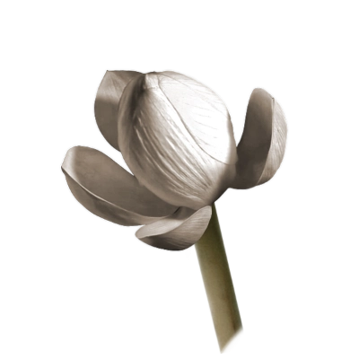

3. A Walk In Peace

You get fit for travelling,  
fit for striving in meditation…  
And samādhi gained while walking lasts a long time.

Caṅkamasutta  
[AN 5.29](https://suttacentral.net/an5.29/en/sujato)

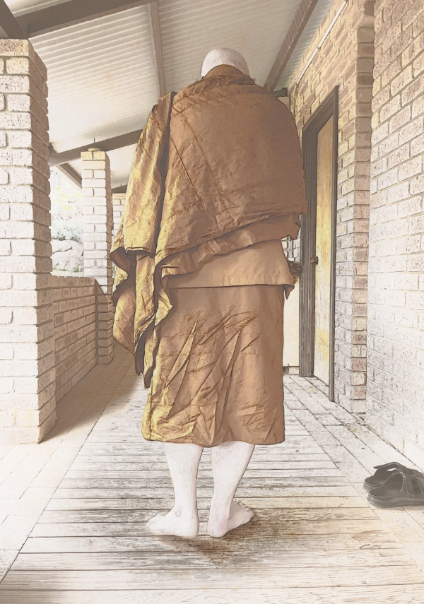

Don’t Be a Zombie

You can do walking meditation anywhere you find quiet and solitude. Make sure you have a nice clear path. The length of the path is not so important.

In our forest tradition, we have walking-meditation paths that are about twenty-five steps long, which is good as it allows you to get into the walking. If you’re limited by space, you can make it shorter, and it will still do nicely.

You just walk from the beginning of the path to the end. You then turn around and walk back again. That’s how you do it!

Try to keep the mind quiet and peaceful. Keep your attention on your feet and your lower legs. Put your mindfulness on the movement of the legs, not on your breath. If you focus on the breath, you don’t notice where you’re going, which is not advisable!

How to be mindful of your legs?

Try wiggling your toes now. Don’t look, just wiggle them. Can you experience them? That’s what we do during walking meditation. We experience the sensation of the path on our feet. If you can, take off your socks before doing walking meditation. Now you can easily feel the sensation of your feet on the floor or the ground. It’s also more enjoyable.

Lift one of your legs. Did you feel any sensations when lifting your leg? This too is what you do during walking meditation. You experience many different movements when lifting your leg. As you lift the leg, does it go straight up? How does it move? I’ve noticed that when I lift my leg in walking meditation, it goes back, and when I move it forward, it doesn’t go straight, but it moves in an arc.

Which part of your foot leaves the ground first? Which part leaves the ground last? What’s the last part of the sole of your foot to lose contact with the ground when you’re walking? When you step down, what part of the foot touches the ground first? These are little snippets of mindfulness, but they make the process of walking interesting.

You’re becoming aware of something you’ve been doing for so many years, but only now are you paying attention to it and feeling it.

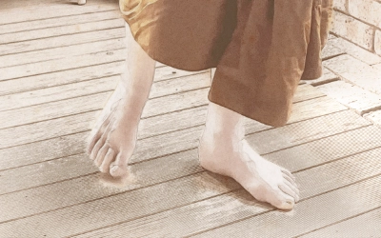

Please note that you’re not walking unnaturally. You’re simply being observant of the movement, mindful of it. After a while, you find that there’s so much to experience in the movement of the legs. It’s becoming more and more fascinating. As your awareness becomes sharper, your steps will slow down naturally. I say that they slow down naturally because you don’t do it deliberately. It happens by itself.

At one time we had a group of meditators using Jhana Grove, while I was over in Bodhinyana Monastery. Some supporters asked me if they could go to Jhana Grove to take a look at the retreat centre. I said they could. When they came back about twenty minutes later, their son, who was about ten or eleven years old, was terrified. I asked him what happened, and he said, “Ajahn Brahm, there are zombies in the retreat centre!”

“Zombies?”

“Yeah, all the people there are walking really slowly!”

To this day, we call slow walking meditation ‘zombie meditation’. So keep it natural and walk at a pace that’s comfortable for you.

When one step is finished, move your attention to the other leg as you prepare to transfer the weight of your body from one leg to the other. This frees the second leg and allows it to start moving up.

Now you observe. What part of the other foot leaves the ground first? What leaves it last? Is it the same with the left leg as with the right leg? How does it move upwards? How does it move forward? How does it move downwards?

At first, you may think this is boring: “I can walk. Why do I have to pay so much attention to it?” But when you start focusing attention on simple things like this, the mindfulness increases. And then what happens? It becomes delightful!

I emphasise this part of the practice because in my experience many meditation teachers don’t emphasise it enough. That is, the joy, the happiness, and the interest in the simple act of walking.

When you’re at the end of the path, turn around—mindfully. This way, you become mindful of how you turn around. Once you’ve turned around facing the way you’ve come, you walk back again.

Say Nothing

If you can, keep your mind as silent as possible, just feeling the sensations in your legs without commentary. Seeing things directly is much closer to reality and much more enjoyable.

There’s a cartoonist from Melbourne, Australia, called Michael Leunig. He was very smart and perceptive. One of his cartoons is just one image. On the right side of the image, there’s a father and son watching a television program showing a beautiful sunrise. On the left side, there’s an open window with an actual sunrise, which no one is watching! I’ve often said that a description can never match the actual experience.

So, when you’re walking, don’t say anything to yourself. The lovely thing about walking meditation is that you can be totally satisfied with just one step. There’s enough going on that you don’t want to be distracted. After a while, you get absorbed, not through force, but by the feelings in your legs drawing you in. It’s almost irresistible. This is when the walking meditation really takes off. You can get very close to beautiful, deep meditation. Though it’s not jhāna, it feels amazing.

Hear Nothing

One day while I was a novice monk living in Bangkok, I was walking meditation in the main hall of the monastery. It took me half an hour to walk from one end of the hall to the other. I wasn’t trying to walk slowly. It’s just that when you get into walking meditation, there’s too much going on to rush it.

I was getting very peaceful. It was delightful just watching all the intricate feelings in my legs as I moved back and forth in the hall.

Then, I heard a sound. It was almost supernatural. My attention was taken away from the feelings in my legs to this weird sound. “What on earth is that?” I wondered. It was quite soft, and I could barely hear it. As I focused my attention on the sound, I realised it was a Thai monk shouting my name, “Brahmavaṁso! Brahmavaṁso!”[6]

I then remembered I was supposed to be at a meal offering in somebody’s house, but I had lost track of time. The abbot had sent this young monk to fetch me. Even though it sounded like he was a hundred miles away, he was actually standing right next to me, shouting in my ear!

I knew I had to come out of meditation, but it took me a full minute to move my head around so that I could look at the monk. I was in a beautiful world all to myself. Everything was going so slowly. I was alert to my body, but my sense of hearing was basically turned off.

That’s what it can be like in walking meditation—you get into your own private world. When you’re finished, you slowly walk to your seat. Then, you sit down to take the meditation even further. You’re already halfway there as you’re so aware, so still, and your mind is so peaceful. When you sit down, the breath is clear and delightful, and it’s easy to go into deep meditation.

Walk a Lot, Sit a Lot

People often feel stiff, or even have aches and pains, after sitting for long periods without getting into deep meditation. To build up the momentum of silence and stillness, my advice is to alternate between walking and sitting meditation.

One of the monks I really respect was previously a farmer in the north-east of Thailand. One day, just as Ajahn Mun’s[7] funeral was taking place in Sakhon Nakhon, he was doing some business in the same town. Out of interest, he walked over to the proceedings and heard a monk giving a talk: “If you want to get enlightened,[8] you have to walk a lot and sit a lot.” That’s all he heard.

Since his children had grown up and his wife was happy to let him ordain, he became a monk. And because the only teaching he had heard was: “Walk a lot and sit a lot,” that was what he did.

After getting up in the morning, he went on alms round, got his one meal of the day, cleaned up, and then walked on his walking path. When he got tired, he sat right there on his walking path. When he came out of sitting meditation, he simply got up and carried on walking. At night, he would sometimes even sleep on his walking path. Being a simple villager, he was used to ascetic conditions, so he didn’t need blankets or a mattress. That’s how he practised.

When I went to see him, he was a powerful monk. Some monks believed he was fully enlightened.

Don’t Rush into Contemplation

Walking meditation can be beautiful and powerful, but please don’t use it for contemplation. Some people do, and it’s a mistake. They walk backwards and forwards, trying to contemplate the Four Noble Truths, Dependent Origination, or some other deep Dhamma.[9]

There’s a sutta[10] called the ‘Paṁsudhovakasutta’, ‘The Panner’ ([AN 3.101](https://suttacentral.net/an3.101/en/sujato)), which talks about the obstacles to getting enlightened. These include thoughts about family, reputation, and so on. It then talks about a lingering obstacle that you have to get through to experience samādhi, which in turn brings you to enlightenment. It’s dhammavitakka, thinking about the Dhamma! When I first pointed this out, some of the monks argued that this was what they were supposed to do. I responded, “Only at the right time.”

Sometimes my mind is so peaceful that I feel I could give the most brilliant Dhamma discourse, but then I realise that this is a last ploy of Māra[11] to stop you from becoming enlightened. The mind hasn’t fully given up the five hindrances yet, and so you’re not seeing the true Dhamma.

What you’re supposed to do is to take the stillness and peace all the way to jhāna. When you come out of jhāna, when the five hindrances are gone for a long period of time, you don’t even need to think about the Dhamma; it just appears. That’s the most valuable Dhamma, the Dhamma that will take you to enlightenment.

Any insight you get from contemplation while the hindrances are still active is not real insight. So, please don’t contemplate Dhamma on the walking meditation path. Just keep being quiet and observe how still your mind can become. When your mind becomes still, go and sit down, and then get into deep meditation. Afterwards, your mind will be so strong that you’re fully ready to realise the teachings of the Buddha.

So that’s walking meditation.

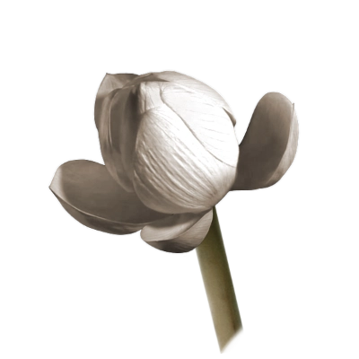

4. Every Waking Moment

We will act with full awareness  
in regard to going out and coming back …  
in regard to eating, drinking, chewing, and tasting …  
in regard to walking, standing, sitting, sleeping, waking,  
speaking, and keeping silent.

Mahāassapurasutta  
[MN 39:11.2](https://suttacentral.net/mn39/en/sujato#11.2)

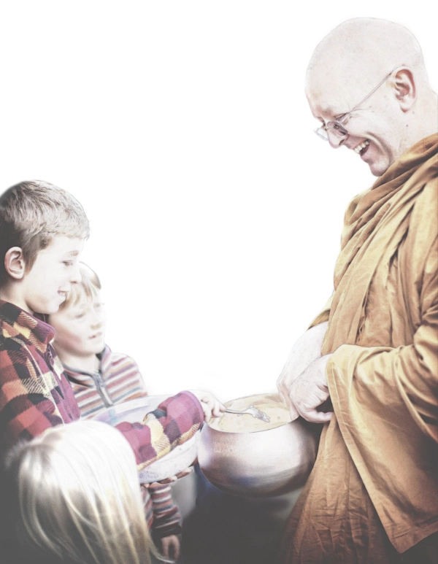

Eating Meditation

This chapter brings us to a few ways of meditating that are rarely mentioned. The first one is eating meditation.

When you’re having your food, how do you eat?

Most people, while chewing their food, look down at their plate and think about what they’re going to have next. They’re in the future. They’ve already got something lined up on their utensil while they’re chewing. They’re not present.

Don’t think about the future. Instead, just be with one mouthful at a time. Taste it, chew it, feel the textures of the food, and get as much nutrition out of it as you can. When you swallow, take a moment to experience the food going down your digestive tract. Only then should you put the next mouthful on your spoon.

Be in the moment. Don’t rush. Take your time and enjoy eating. It’s good to develop gratitude for the food that’s on your plate. Take a moment to acknowledge the generosity and kindness of the people who made it for you, or if you made it yourself, all the hard work that was necessary to bring it to your plate. Dedicate the meal to your practice. Remember that you’re eating to nourish your body so that you can continue to practise the beautiful Dhamma of the Buddha and share your happiness with others.

If you do this, you’re not just doing walking and sitting meditation, you’re also doing eating meditation.

Lying-down Meditation

We’ve talked about sitting meditation, walking meditation, and eating meditation. How about lying-down meditation?

When people get sick, they may find it hard to sit or walk. Does that mean they can’t meditate? Of course not! Lying down will probably be the last posture you meditate in! It’s very suitable when you get old, sick, or bedridden. That’s one of the reasons it’s useful to develop this meditation.

When you’re meditating lying down, don’t lie in the same position as you sleep in. I go to sleep lying on my left side, sometimes on my right side, with my hand underneath my head, but I never fall asleep on my back. I reserve that position for lying-down meditation. This means that when I lie on my back, psychologically I’m telling my mind that I want to meditate.

When you’ve found your best lying position, make your body as comfortable as you can. Then do body-scanning. Because you are lying down, you can really relax to the max. After the body scan, you can start watching your breath.

This posture is helpful because you don’t get sore from it. It’s very comfortable for your body, which means you can have a nice, peaceful meditation.

When I was about twenty-four years old, I contracted scrub typhus and was the sickest I’ve ever been. I was in the monks’ ward in a very basic third-world hospital in Ubon Ratchathani in the early seventies. And because it was over the Christmas period, there was only one nurse on duty.

When I first got admitted, they put a drip in my arm. The nurse was present during the day, but in the late afternoon, the nurse just disappeared. At six-thirty p.m. the replacement nurse hadn’t shown up, so I asked the monk in the bed next to me where the night nurse was. He told me there was no night nurse. “What happens if somebody gets really sick?” I asked. “It’s just unfortunate kamma,”[12] he replied.

That wasn’t reassuring at all!

I had a fever for weeks and felt really weak. One day Ajahn Chah came to visit me. I was just a young monk, and this great hero monk had come to visit me! I felt so honoured. I was waiting for him to give me an inspiring talk or some nice mettā,[13] but instead, he just said, “Brahmavaṁso, you’re either going to get better, or you’re going to die.” Then he left.

How can you argue with that piece of Dhamma?

I didn’t get better and didn’t know what to do, so I decided to meditate. There was no way in the world a person in my weak condition with a high fever and no energy could sit up to meditate. So, as I was lying there, I decided just to let go.

I’m not quite sure exactly what I did or what happened. Maybe it was based on the story of the *Emperor’s Three Questions.* I may have asked myself:

* What’s the most important time?  
  *Now.*
* What am I aware of right now?  
  *A yucky fever, a body with no energy.*
* What’s the most important thing to do?  
  *To care for it.*

And with that type of attitude, I soon got into an incredible, deep meditation. Imagine you’re sick with a high fever and are aching all over, and now you’re blissing out!

The first thing I noticed when I came out of that meditation was my posture. I know that people say that we have to sit cross-legged with a straight back, and we’ve got to have our right palm on the left palm with the thumbs slightly touching to keep the energy connected. But if you’re sick with a fever in hospital, your body is all over the place. That was the posture I found myself in. I’ve never seen such a posture in any book on meditation! But it worked for me. I could let go of my body.

If you’re lying down in meditation, especially at that time of your life when you’re sick or dying, don’t worry too much about where your legs or arms are as long as you’re comfortable.

When you’re sitting in meditation for an hour, your body can get a bit tight sometimes, but when you’re lying down, you’ll be more comfortable and can become peaceful easily. When you look after the health and comfort of your body, one big distraction has been taken away.

Relax to the Max

One way of developing mindfulness is simply by asking your body: “How are you, body?” If you ask an honest question, you’ll get an honest answer. Don’t ignore it. As soon as I ask that question, I become aware of my body and the best position for it.

Treating your body this way means that you are kind to it. You can then close your eyes and just be aware of your breath or whatever meditation you’re doing. You’ll then get some nice, peaceful meditation.

So, this is how we do meditation: start with awareness of our body. The Buddha sometimes says that we start our meditation with kāyagatāsati, mindfulness of the body. An important part of this is to be able to relax the body. I call it ‘relax to the max’.

I remember teaching meditation in Malaysia for the first time many years ago. I was told that the biggest problem meditators had at that time was samādhi headaches. Samādhi means peace and stillness, but your samādhi creates a headache?!

I found out what the problem was: they were focusing on the tip of their nose all the time. Try this: keep your eyes open and focus your attention on the tip of your nose. I bet you went cross-eyed!

The meditators had their eyelids closed because they were meditating, but they were cross-eyed underneath their eyelids. It was that tension that caused the headaches. I told them they didn’t need to watch the tip of their nose. They just needed to be mindful of the breath.

These days I tell people who haven’t meditated before to close their eyes and count three breaths. After the third breath, they can open their eyes. Anyone can do that with no problem at all. Then I ask them how they knew the breath was going in or going out. They all say, “I just know.” You know whether your breath is going in or going out without any need to focus on the tip of the nose or to locate it in your body. This is the kind of knowing you need. There is no need to refer to the body.

That is far more effective because the purpose of meditation is to let go of your body. The body is irritating. You don’t have to be old to realise how irritating it is. Even fit and healthy young people have irritating bodies. It’s so beautiful when you’re not aware of the body at all. You’re aware of the breathing, aware of other things, but not of the body. You are beginning to experience freedom.

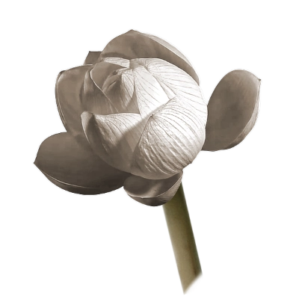

5. The Beautiful Breath

Mindfulness of breathing,  
when developed and cultivated in this way,  
is very fruitful and beneficial.

Ānāpānassatisutta  
[MN 118:22.1](https://suttacentral.net/mn118/en/sujato#22.1)

Don’t Disturb the Noise

Many years ago, when I first started teaching at Bodhinyana,[14] I got some advice from the abbot at that time, Ajahn Jāgaro. One day he said to me, “Ajahn Brahm, you’re very good at teaching about nimittas and jhānas, but not many people can get there easily. Why don’t you focus more on the beginning part of meditation? How can we watch the breath with ease?”

I really took his advice on board.

As you know, I’m a bit rebellious, and I’ve always found rebellion to be important. I was encouraged to be rebellious when I was at university. To get breakthroughs in science, like in theoretical physics, you have to see things in a different way. So, like a good scientist, when I was given advice about meditation, I questioned it.

Take the Buddha’s instruction in the Ānāpānassatisutta ([MN 118:17.1](https://suttacentral.net/mn118/en/sujato#17.1)), the Discourse on Mindfulness of Breathing, where he says to his followers to find a secluded, quiet place.

First of all, how many secluded, quiet places are there in the world? Even here at the meditation retreat, there’s always somebody telling silly jokes (me?) and people laughing their heads off, making a lot of noise, or somebody coughing, banging a door, or doing something. The sound of the door banging finished hours ago, but we keep thinking about it and complaining about it. That’s called disturbing the noise.

It’s hard to find perfect silence anywhere, especially in a town or city. So, the first thing to learn is how to make a place quiet by not disturbing the noise. It’s one of the skills I learnt from Ajahn Chah that I’ve found very useful when meditating in a less-than-ideal environment.

A few years ago, the Burmese community here in Western Australia wanted to stage a peaceful protest against the government in Myanmar at that time, and they invited me to join them. Because monks don’t protest, I asked them what they wanted to do, and they said, “We’re just going to sit in meditation opposite the Hay Street Mall in Perth.”

I remembered that there was a Uniting Church outside the mall, and I realised we could sit on the pavement just outside. That was allowable as a monk. So, I agreed. Not because I was joining the protest, but because I wanted to see if I could sit for a couple of hours on the hard concrete pavement with no cushion and with all the noise. It was like a test.

When I got there, I found it was noisier than I’d expected. Opposite the church was a video game store playing music, which was much louder than the traffic. To make the place quieter, I created an imaginary sound-proof bubble around myself. You can try this yourself. It just takes a little bit of imagination.

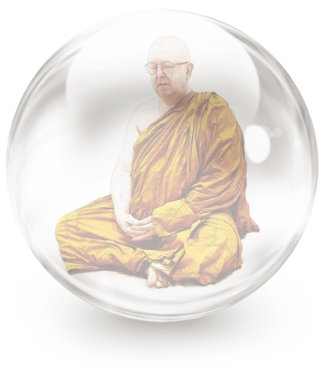

So, I was inside this bubble. At first, I could hear the sounds, but I wasn’t listening to them. Hearing a noise and listening to it are two different things. When you listen, you’re trying to figure out what it means, and that engages your mind and disturbs the noise. But because the noise from that store and the traffic was fairly constant, it soon disappeared. That’s how the bubble works. When you don’t give importance to the noise, it vanishes.

This is how you can find a calm and peaceful spot to meditate anywhere in the world. It’s possible to do so, and once you know it’s possible, you don’t need quiet all the time.

Vanishing Senses

Even though you can meditate anywhere, at first, it’s easier to do ānāpānassati or breath meditation in a place where you’ve got little to disturb you. So first try to find a nice, secluded place.

The next thing is to sit up with your back straight. I took that seriously for a while and always tried to make my back straight, but how about people with back injuries? The last thing you want to do is to torture such people when they’re meditating. The answer is to sit in a posture which is comfortable for your body. The reason this is important is that a main aspect of meditation is to calm your body down enough so that it disappears.

In meditation, when your body becomes still, the senses gradually fade away. When you close your eyes, you can’t see anything, so the sense of seeing is gone. In the beginning the sense of hearing is active, but as you go deeper into the mind, sounds fade away also. You can’t smell, or taste anything, and physical touch also starts to disappear. When your five physical senses disappear, the only sense left is the sixth sense, the mind.

Many people have all sorts of theories and philosophies about what the mind is, but in meditation you come face to face with it. Now you understand what this mind of yours is, and that’s important data from which you’ll get insight. One of the interesting insights you get when the five senses vanish and the sixth sense manifests is that there is nothing to fear from death.

What is death anyway? Death is when your five senses disappear. You can’t see, hear, smell, taste, or touch. If a doctor comes to find out whether you’re dead or not, what do they do? Simple things like shining a light in your eyes. Or they speak to you, “Hello, are you alive?” Or they poke you. When you don’t respond, they think you must be dead.

Knowing that the five senses vanish in meditation is an important piece of information. If you see somebody in deep meditation, but you can’t see any breath or other activity, don’t panic. Just feel their body. If they are still warm, you know they are alive. The main difference between a person in deep meditation and a person who is dead is the warmth of the body.

Make Mindfulness Matter

Let’s come back to ānāpānassati. So, you go to a reasonably quiet place and sit down in a comfortable position because the last thing you want is for the sense of physical touch to keep bothering you with uncomfortable feelings. You can meditate and get into deep meditation with pain or even chronic pain, but it’s much more difficult. It’s easier with a comfortable body without too many aches or pains. You want to be comfortable without being sleepy. That’s why sitting up straight is great if you can do it.

In the Ānāpānassatisutta, after finding a comfortable position, the Buddha says we should establish mindfulness. Here we encounter the Pali word parimukha. Many people translate it as ‘in front of you’. But what exactly does this mean? In front of my nose? I’ve never identified with my nose. Where are we supposed to put our mindfulness? I don’t think this is an accurate translation of the Buddha’s words in this context.

‘In front’ here doesn’t mean in front of a particular spot on your body. Rather, it means to put mindfulness in the front of your list of things to do; that is, to give mindfulness priority at the beginning of meditation.

So, the phrase parimukhaṁ satiṁ upaṭṭhapetvā, as it occurs in the sutta, should mean ‘having made mindfulness a priority’. To prioritise mindfulness, you apply any type of skilful means or technique to get mindfulness really strong. Otherwise, you won’t be able to stay with the breath.

This is not the mindfulness of the breath or mindfulness of anything in particular. It’s just mindfulness. Make mindfulness strong, first and foremost.

Body Scan with Kindfulness

I remember a meditation teacher leading a retreat nearby and one of our monks going to attend his retreat. He was honest with our monk, telling him that he couldn’t stay with the breath for long—his maximum was watching five breaths in a row and then his mind would wander off. His main issue was that he didn’t create enough strength of mindfulness first to help make it easy to watch the breath.

So, how do we make mindfulness strong?

When I teach meditation, I usually encourage people to start with sweeping the body. It’s very helpful for building up mindfulness.

How are your toes feeling? How are your feet feeling? How are your ankles feeling? Do the body sweeping very slowly. Usually when I do a guided meditation, it takes at least twenty minutes just to go through the whole body.

The reason I start at the toes is that they’re usually not a problem, so we can develop mindfulness and kindness easily. By the time we get to the upper part of the body where there are often lots of aches and pains or even diseases, our mindfulness is already quite strong.

Sweep up your body and if you feel there’s something not quite right, just know that there’s something off there. You don’t have to give it an accurate description. Stay there with your mindfulness and add kindness, the two together being what I call ‘kindfulness’. You’ll find that the body relaxes, and some unpleasant sensations disappear.

Once I had a serious case of food poisoning. I was in my cave at the time, and I wondered if I should crawl out to the nearest phone to call an ambulance, but I decided to meditate instead, feeling the body and just being with it, not trying to escape. Whatever was in front of me was the most important object in the whole world, and at that time, it was the feeling in my tummy and the sound of me yelling, “Ahhhh!” I couldn’t help it; the pain was so intense.

Then I noticed that the intensity of the pain lessened as I added kindness to my mindfulness, making it ‘kindfulness’. The cramps in my tummy hurt less each time I sent kindfulness there. After half an hour, there was no pain or cramp at all.

How does it work? I don’t know, but I had a cartoonish idea of what was happening. Food poisoning is usually some bacteria multiplying in our tummy, wrecking the peace of the stomach. So, while I was meditating, I imagined all those bacteria with their little appendages sticking out. I imagined them sitting cross-legged with the appendages one on top of the other, quietly meditating in my tummy. After a while, they stopped causing problems.

We’re not all health professionals, so we may not have the language to describe the feelings we are experiencing, but this is fine as we don’t need language here. All we need is to learn that our body is getting more at ease and that kindfulness is getting stronger.

When you activate kindfulness, it makes your body feel good. This is very useful for meditation because during a body scan, your feelings of the body only exist in this moment. You’re not really concerned about the pain to come in the future or the feeling that happened a moment ago.

Body scanning centres you in the present.

Once you’ve done that basic kindfulness and strengthened it, it’s very easy to let go of the body.

I recall doing a lunchtime meditation session for executives in Singapore. I was surprised by the results. Some of those executives told me, “I was scared. I was sitting there, and then my hands disappeared!” It was just the feeling in their hands that disappeared. They were getting peaceful.

What disappears first from your body when you meditate? One of the strongest sensations I have when I start meditating is the pressure of my buttocks on the cushion. That feeling disappears first because it doesn’t change, and after a while, I can’t feel it anymore. Even if you have a little itch, that too disappears easily. After a while, your body is comfortable. Your body becomes still and then disappears.

What happens when the body disappears? You can’t feel your head, you can’t feel your arms, you can’t feel your legs—your body is basically not there. There’s only one thing still moving: your breath. It’s the only thing left for you to watch.

Let the Breath Come to You

You’ll find that when the breath comes to you because everything else has disappeared, it is much more peaceful and easier to watch. The reason is that when you do anything, when you “go to the breath”, you tend to control it—it’s just psychology. You no longer stand back and watch from a distance. In meditation your job is simply to watch the breath as a passenger, not as a driver nor as a backseat driver.

When the breath comes to you, it will be easy to watch. And it will be peaceful.

The breath is a fantastic meditation object. Give it importance. Respect it. Honour it. Don’t tell the breath what to do. Be a friend to it. I like the idea of being a friend of whatever you’re watching. This way you give it both importance and kindness. Because you love being with your friends, you will stay with your breath for much longer than five breaths. And even if it goes, it will come back.

Let me give you a simile to show how being kind to your friend works really well.

In the dry season in Thailand, the villagers would take their water buffaloes out to the fields to graze. When they took them past our monastery, the buffaloes would get spooked because a forest monastery looked just like a tiger-infested jungle . One of the water buffalo owners held a string that was tied to the buffalo’s neck, with which he led it to the fields. When his water buffalo got spooked, it lifted its head up. The farmer tried to hold the water buffalo back as it ran off, but because the string was wound around the farmer’s finger, it pulled the top of his finger right off! He came to our monastery, and we took him to the hospital to get his finger bandaged.

Later, we felt grateful to him for the story. If he’d just let go of the water buffalo, it would only have run maybe twenty or thirty metres. The farmer could then have walked after it, gently picked up the string and led it back to the fields. But we would have missed out on a great lesson on how to be with our mind during meditation!

When you’re watching the breath, the mind sometimes wants to go off somewhere. So, you say, “Off you go, dear!” Later, you can walk after it and be with it again, or it will just come back to you. With friendship, it’s easy.

The Beautiful Breath

You can make the breath a bit more interesting by observing whether it’s a long or a short breath, but don’t label it. Short, medium, or long—it doesn’t really matter. It just means you have something more interesting to watch. Also, you can reflect that the breath is what the Buddha watched. That’s how the Buddha meditated. So, respect it and honour it. It’s a special meditation object.

If that doesn’t work, you can use a mantra. In the Thai forest tradition, we use ‘Buddho’, referring to the Buddha. Breathing in, you say, “Bud,” breathing out, “dho.”

When I came here and tried to teach ‘Buddho’, the Australians didn’t like it, as it didn’t have the same meaning for them. I had to invent some other mantras to go with the breath, something more meaningful. My first suggestion was: “As you breathe in, say ‘shut’, and as you breathe out, say ‘up’. ‘Shut up!’” Laughter is good for meditation, remember?

These days I tell people to breathe in ‘peace’ and breathe out ‘happiness’, which is what you want in your mind. Or you can see the out-breath as a letting go. If you’ve got an illness, breathe out ‘sickness’. In the same way, let go of anger. Let go of wanting. Let go of tiredness. But you don’t want to write a big essay with every breath. Keep it simple.

When you make the breath interesting, it’s easy to watch. After a while, once the breath is present, you don’t need to use those mantras because the breath is nice in its own right. As you get calmer, it becomes more peaceful and easier to be with.

The next stage of ānāpānassati is seeing the whole breath. This is where it starts to get interesting.

Look at my finger.

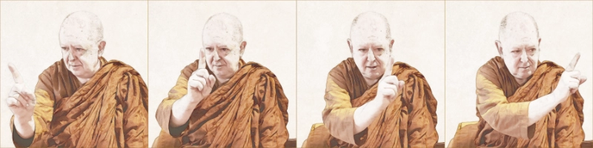

It’s moving slowly from left to right, and then right to left. I can notice every time the finger passes my eyes. The next stage of meditation is seeing the finger from the very beginning on the left, all the way to the right. You see a pause there, then the finger moves from the right all the way back to the left. You see the whole of the in-breath and the whole of the out-breath. You don’t miss any of it. It is all quite natural. It just happens because you really start to focus in on the breath. When you focus in on it, naturally there’s nothing else disturbing you.

You start to notice evenness or constancy in the breath because you’re just focusing on the experience of breathing in this moment and there’s hardly any difference between the in-breath and the out-breath. It all becomes quite even.

The Paṭisambhidāmagga[15] compares this to sawing a piece of wood. At first, you can see the handle of the saw as well as the teeth at the beginning and in the middle. But as you focus in more and more, you can only see the few teeth that are touching the wood. Likewise with the breath: you don’t know if it’s an in-breath or an out-breath, if it’s the beginning or the end—you just see what’s happening right in the present. That’s important because once that happens, the physical breath starts to disappear.

Anything even or constant, such as a background sound, will disappear. You can’t hear it anymore. The feeling of your bottom against your seat—a moment ago you couldn’t feel it, but now you can because I’ve just pointed it out to you. So, the breath is disappearing. When you reach this point, don’t worry; it’s supposed to happen. It’s just the breath calming down.

When you do this properly and you are really with the breath, your mindfulness becomes more powerful, and whatever you see after meditation becomes beautiful. Sometimes when you come out of meditation, you open your eyes and feel: “Wow, the room is so interesting with different colours and textures.” Things become beautiful when the mind is simplified and strong. That’s the nature of the beautiful mind.

The Beautiful Mind

With a beautiful mind, you start to experience joy and happiness, pītisukha.

Where does that feeling come from? At this stage, you’re not feeling the breath with your body anymore. The Buddha calls this the cittasaṅkhāra. Cittasaṅkhāras are the creations of the citta, the mind. The beauty and happiness is not inherent to the breath; it’s what the mind adds on to it. It is cittasaṅkhāra that you’re seeing: the joy with the breath. The breath becomes very delightful.

There’s a monk whom many of you know: Ajahn Gunha. When he came to Perth, we asked him to give a talk about meditation because he’s a really good meditator. The only thing he said was: “Breathe in… ‘Sabai.’ Breathe out… ‘Sabai.’” ‘Sabai’ is a Thai word meaning comfort or ease. That’s all the instruction he would ever give. Yet it’s brilliant because the happiness and bliss that come with the breath start with comfort and ease.

Before you read on, take a pause for a moment, close your eyes, and breathe in the most beautiful, delicious, wonderful breath you’ve ever breathed in your whole life. Then, breathe out the most amazing breath you’ve ever breathed since you were born…

Could you do that? Was it joyful? Okay, close your eyes, and do it for another three hours!

You finally get to this natural state of just watching yourself breathe, and it’s simply wonderful. After you have experienced the whole cittasaṅkhāra, you calm it down, and it becomes nice and peaceful.

What happens then?

This is when you experience the mind. This is called cittapaṭisaṁvedī in the Ānāpānassati Sutta. What does it mean? The joy at this stage is so strong that you get a direct perception of your own mind. This is when nimittas appear. They are right inside the delightful breath.

A nimitta is a beautiful and bright light. It’s like looking at the sun, but you’re not seeing it with your physical eyes—you’re seeing it with your mind. The nimitta generally appears as a light because sight is our dominant sense. We perceive the mind by the closest analogy in the five senses. It’s not a light. It’s just how we interpret it. That’s the reason why a nimitta can be as bright as you want. It won’t make you blind, even though that’s how it might feel!

When you experience a nimitta, you shouldn’t control it, nor should you get excited. It’s come to you because you’re ready for it. Don’t try to alter anything. Just be calm and stay with it peacefully.

A Still Forest Pool

The experience of a nimitta can be explained with the simile of the still forest pool. This is what Ajahn Chah told me personally. He said that in the old days, when monks wandered around to find quiet spots to meditate, called ‘tudong’ in Thailand, sometimes they would go to the jungle. When travelling through the jungle, they had to find a source of water in the late afternoon to fill up their water bottle, to have a wash, and to wash their robes. When they found one, they would set up their mosquito net, a ‘klod’ in Thai, close to the water’s edge, and then sit there all night.

On the full-moon nights, they might watch the wildlife coming out of the forest to drink and bathe. The nature of animals is to be wary, especially of humans. If they think there’s a human being close by, they return to the jungle.

If you sit perfectly still, the animals won’t be able to sense you, and they’ll come out. Sometimes a whole family will come out with their cubs, playing in the water. Sitting still, you can see and enjoy all that. In the same way, sometimes incredibly rare and beautiful animals will come out to drink, bathe and play in your ‘still forest pool’ mind. These animals, said Ajahn Chah, are the jhānas.

You just have to be still. Don’t react. Don’t get excited. Don’t be afraid. Just wait, and they’ll come. It will be amazing.

All this starts to happen at the stage of ānāpānassati when you see your mind. You’ve acquired a high degree of confidence in the object, so you don’t need to do anything. The nimitta just gets stronger and stronger. If your nimitta is a light, the light gets brighter, and so does the joy and the bliss.

When you get to this stage, you don’t worry about what you should be doing, because the bliss is so strong and lovely. It’s one of the best experiences you’ve ever had.

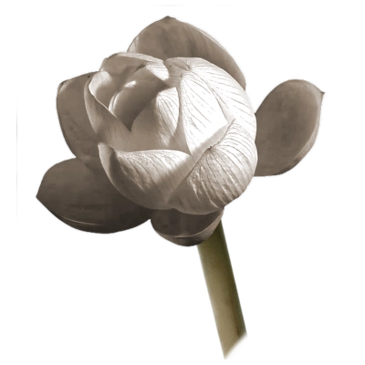

6. The Lotus

Suppose there was a blue water lily,  
or a pink or white lotus.  
Though it sprouted and grew in the water,  
it would rise up above the water  
and stand with no water clinging to it.

Pupphasutta  
[SN 22.94:8.1](https://suttacentral.net/sn22.94/en/sujato#8.1)

Anālaya

I’ve spent much time on the beginning stages of meditation because once they are in place, the later stages will just happen naturally. So, let’s prepare the ground a little bit more before we come to the next stage, the jhānas.

This is a good place to introduce one of my favourite similes. I call it the ‘thousand-petalled lotus’ simile. The lotus has always been a key symbol in Buddhism. There’s always a lotus somewhere in Buddhist temples, and the Buddhist scriptures have many wonderful similes related to lotuses.

One such simile is the one about the lotus growing in the mud, which refers to the fact that we all grow when things are difficult. Life is rarely easy, and each one of us is often embroiled in difficult situations. This is just the nature of human life. Good lotuses grow through it all. The mud, the difficulties or the suffering in life, is important as sustenance and fertiliser to drive us up, out of the dirt, and through the surface of the water towards the sunlight above.

Another lotus simile is very useful for the times when we’re affected by other people’s attitudes towards us. When people criticise or even praise us, we can imagine or visualise being like a lotus. When water falls on a lotus petal, the water always drips off and leaves no residue. If somebody urinates on a lotus, it doesn’t keep any of it—it all drips off, and the lotus still smells beautiful. Likewise, if people pour perfume over a lotus, the perfume drips off, leaving no residue. In the end, the lotus always smells like a lotus.

Each one of you, no matter who you are, will receive a fair amount of criticism. Some of it is deserved, but most of it isn’t. Other people don’t really know who you are or what you do. So, let it ‘drip off’.

Do you know what Ajahn Chah said about criticism? In the north-east of Thailand, one of the worst things anyone could call you is a dog. Ajahn Chah told his monks that if anyone called us a dog, we shouldn’t get upset. Instead, we should look at our bottom to see if we had a tail. If we didn’t, then we weren’t a dog. End of problem. However, if we had a tail, then we should say: “Thank you for pointing that out to me.” In other words, you don’t need to react negatively to criticism.

When anyone uses bad speech against us, we should act like the lotus and let all the bad words drip off. Even with the nice words you hear, let them drip off too. You may be in a situation where people are cursing you or praising you. You can’t stop it, but at least you can let it slide and walk away, allowing no residue to stick. You don’t react. You’re like a lotus.

This is actually one of the four ways of letting go mentioned in the suttas.[16] It’s called anālaya, or non-clinging—nothing sticks to you. Things happen in life. You may have a beautiful meditation or a terrible meditation. Neither belongs to you. Everything just drips off, and afterwards, you’re still peaceful. You hold on to nothing, and you keep nothing.

The Thousand-Petalled Lotus

If you look at a lotus at night, it’s all closed up. If you look closely, you can see that the outermost layer of petals aren’t really petals—they’re more like a sheath, thick and strong. It’s those outermost petals that take the impact from the wind, the dust and everything else at night. They protect what’s inside the lotus.

In the morning, when the sun comes up, the light and the warmth of the sun on the outermost sheath opens up that lotus. You can’t peel the lotus open, as that would damage it—you have to wait for the light of the sun to open it and reveal the next layer of petals. The warmth of the sun stands for kindness, and the light for mindfulness. In short, the warm light of the sun is kindfulness.

If this body is still painful and active, you can’t be aware of your mind. However, when you look at your body and mind with kindfulness, you can actually see it as it is. Because you’re kind to it, shining warm light on the outermost petals of your lotus, your body will soon relax and disappear. You can then go inside the first layer of petals in the lotus to the world of the mind.

Sometimes people confuse thoughts about the world with the mind itself, but thoughts aren’t the mind. They’re normally just echoes of the body and the five-sense world.

You can only go into the world of the mind, the inside of the lotus, when you are totally peaceful and the body vanishes. You use kindfulness to stay there and see what happens. This is when you feel like you’re going into what I call the ‘centre of time’. You go into the present.

Many meditators tell me they can become present only for a moment before their minds drift back to the past or jump ahead to the future. So how can we let go of thinking about the external world, the past, and the future?

By adding kindness.

Kindness is the missing factor to help you let go of the past and the future. I don’t know what you did yesterday. Did you make a mistake? Did you break any of your precepts? If you don’t have this beautiful kindness, which includes forgiveness, you can’t let the past go. It will keep coming up and bothering you. But if you give it kindness, it’s amazing how easy it is for all that to vanish.

With kindness to the past, you can forgive everything. You’ve got a choice. You can’t change the past, but you can choose to change the way you regard it. You can be negative about the past, or you can think of it as wonderful fertiliser.

The Nimitta Petals

The origin of the fertiliser simile comes from my experience during my first years as a monk. After my basic training, I was allowed to leave the monastery. In my wanderings, I discovered a beautiful cave where I ended up spending a lot of time meditating. Inside the cave, there were bats, and right outside was a papaya tree that received all the bat droppings as they flew in and out of the entrance. That particular papaya tree gave the most delicious papayas I’ve ever eaten. I realised that when I was eating the fruit, I was essentially eating bat poo, transformed into delicious papaya.

If you’ve had some difficulty in the past, try to see its benefit. There are always benefits. When you see those benefits with kindness, then you’re using those bad experiences, the bat poo, to let go of difficulties more easily, no matter what happened to you or what you may have done. In addition, that attitude of being kind to the past and the future encourages you not to be afraid, which further aids the process of letting go.

With kindness and wisdom, the past and the future—time—disappears. When the petals of the lotus are opening up, it’s as if the present is right in the middle of time. Each layer of lotus petals is more beautiful than the previous one, more fragrant and more delicate. Then, right in the middle of the present moment, you’ll notice that you’re silent.

There’s nothing much to say about now. Most conversations are about what happened in the past or what might happen in the future. You can’t say much about what’s happening right now. You can’t fantasise because fantasising is like dreams of the future or memories of the past.

Being in the present, you get silent.

Imagine you’re listening to music. There is no past or future when you’re listening to great music. You have to be right there in the moment to really appreciate it and enjoy it. Right now is where the beauty is.

The thousand-petalled lotus is opening up, and you’re going inside it. Silence is in the middle of the present moment, in the middle of time. Time is in the middle of your mind. And the mind is in the middle of your body. You feel like you’re going inwards.

This is an important point. Many people feel that they have to go onwards, always onwards to the next thing, the next level. But in meditation, you neither go onwards nor backwards, but instead inwards, right into the centre of silence.

The present has opened out. Silence has opened out. And right in the middle, you can feel your breath. The breath is coming in, the breath is going out. You don’t do the breathing; it’s just what the body does. When you don’t go looking for the breath, but just experience it, it’s always very beautiful. The deeper you go into the lotus, the more refined the colours of the petals, and the deeper and more beautiful the fragrance is.

I give this simile because people often ask me what they have to do next after watching the breath. “Now what do I do?” “Have we got there yet?” “Is this jhāna?” “Is this Nibbāna?” Instead of thinking like that, enjoy the present. Be with it. Be mindful. Be kind. Then you’ll find that those petals of the mind open up. And what do you find in the middle of the breath?

The delightful breath.

That’s the way the mind sees the breath. It is one thing when you feel the breath with the fifth sense of physical touch. It is a different thing when you experience the breath with your sixth sense, the mind. It’s the same thing, but it appears different. This movement from one sense to another is one of the reasons you see the breath as delightful. Now the breath is happy, fun, and enjoyable.

I often call this the tipping point of meditation because you don’t need to put effort into it anymore once the joy starts to come up. You don’t need to struggle or strive. You stop asking, “How long must I sit in meditation for?”

When the tipping point comes, meditation becomes incredibly attractive. You want to do it. You can feel the benefit in this moment, as well as the benefits that come afterwards.

The lotus petals are now very beautiful and fragrant. You can just watch and enjoy them all day. The lotus has opened up to the delightful breath, a delight that just keeps growing and growing. And when those delight petals open out, do you know what’s inside?

The nimitta petals.

The nimitta is right inside the delightful breath. As the joy gets stronger and stronger, these beautiful lights, the nimittas, eventually appear.

When you first experience a nimitta, it may appear complicated. The problem is your reaction to it. Some people have expectations and can experience too much excitement. You should then remember that these are just another layer of petals in the lotus and that there are more petals inside. After a while, the mind settles down, the nimitta becomes simpler, and the lotus opens further.

Sometimes people get the delightful breath and the nimitta appears, but it doesn’t stabilise, and it moves away from the delightful breath. It’s like the person is in between the delightful breath and the nimitta. To use our lotus simile again, it’s like the next layer of petals is only half opened. You can see the nimitta inside, but you can also see the delightful breath.

At this point you should not focus on the nimitta nor on the delightful breath. You shouldn’t do anything, except being kind and mindful. If you have enough letting-go energy, then those petals will fully open. If not, they will close up but may open up again later. When the nimitta eventually stabilises, there’s so much joy and fun. Those lotus petals are gorgeous.

Open the Door of Your Heart

Some people may say, “It’s only a nimitta. What about jhāna? I need a jhāna. How do I do that?”

You don’t do anything. Just remember to be mindful and kind.

It’s beautiful being kind. The best description I have of kindness is to open the door of your heart no matter what you’re observing, whether it’s a beautiful and stable nimitta or a nimitta fading away. Whatever it is, open the door of your heart unconditionally with no judgement. Just let things be. Part of kindness, of mettā, is letting things be.

So, we’re observing this nimitta, and if we’re just kind and aware, it opens out, and in you go. Now you’re entering jhāna.

Jhāna is right inside the nimitta.

Sometimes you’re just on the edge of the jhāna, having a lovely nimitta experience. It’s like the jhāna is right in front of you, and you ask yourself: “Shall I go in? Shall I not?” It seems scary at first simply because you don’t know where you’re going or what’s going to happen. Going in is very joyful! Go for it! Let yourself go. Let the joy and the bliss overcome your fear. Before you know it, you’ll go deep into a beautiful meditation.

Some people may ask which jhāna it was. Please don’t worry about such things until after you’ve come out of it. Because jhāna hasn’t got any “width” to it, because it’s ekaggatā,[17] it’s impossible to describe it while you’re in there; you can only describe it afterwards. Once the jhāna is complete, you will have a good memory of it. You can then turn the memory around this way and that way to discover whether it was a jhāna, and if it was, which particular one. It’s a powerful experience that’s different from anything you’ve experienced before, and that’s why it leaves such an indelible memory.

Jhāna is powerful, stable, and long-lasting. Some experiences are what I call ping-pong jhāna. You go in and then straight out, but that’s not really a jhāna. It’s just a glimpse.

A real jhāna is when you’re in deep meditation for a long time. The deeper the jhāna, the more time you’re in. There’s no way you can be in a deep jhāna for ten minutes or half an hour. You’re in these states for hours.

Set the Jhāna Alarm

Don’t be afraid of jhāna. If you’re worried, you can try programming your mind when you feel you are getting close. When you start meditating, tell yourself three times, “If jhāna happens, I’ll come out by eleven o’clock.”

If you want to get some confidence in this technique, set your alarm clock to five minutes after your intended wake-up time before you go to bed. That will relieve your fear of waking up late. Then, tell yourself as you’re ready to go to sleep, “I’ll wake up at four a.m.” Say it in your own words, as simply as possible, and give it as much attention as you can. Once you’ve said it, forget it.

During my first meditation retreat I was told to do that. I’d never done anything like it before, but it worked every morning. I woke up within one or two minutes on either side of the chosen time. I did set the alarm clock, but I never needed it. It’s amazing just how your mind can take that kind of instruction.

Even when there’s something I have to do, instead of writing it on a piece of paper and putting it on the office wall, I sometimes just make a resolution: “I must remember to send that email to the BSWA in two days.” After two days, I get the email sent. A well-trained mind is like an obedient little dog.

So, you get to the first jhāna, and right inside of it, right in its centre, you experience the second jhāna. The difference between the first jhāna and the second jhāna is the quality of the bliss.

In each one of these jhānas, what are we watching? Are we aware of the breath? No. We’re still breathing, but we’re not aware of it. Instead, we’re aware of a beautiful mental bliss. And we don’t have to force our mind to be aware of it because it’s incredibly satisfying and great fun.

Some non-Buddhist meditators who seem to have experienced the first jhāna call it union with God. If you’ve experienced jhāna, you know why they make that statement. It’s because you feel like you’ve disappeared. Your sense of self is gone, and it’s incredibly blissful. It’s not just intense pleasure; people also interpret it as pure love. There’s hardly any difference between the experience of pure, powerful love, or mettā, and that of bliss. So, some people feel that they’ve had a union with God.

There are some interesting stories about jhāna experiences. I remember one monk, Venerable Sudhammo, from Java in Indonesia. When I met him, I could feel straight away that he was a powerful monk.

He told me that when he was young, he decided to go into the jungle in Java to meditate like a rishi or hermit, even though he wasn’t ordained. He said that one day when he was meditating, he got very, very still. A star, like an angel, came to him, and he married that star. His English wasn’t perfect, but you could understand that he was talking about a nimitta. He didn’t mean that he and the star had some sort of marriage ceremony; he meant that he united with the star—he went into it.

When he came out of meditation, many days had passed. He knew that because the whole jungle looked different, with trees fallen over and water everywhere. He found some villagers and asked them if the forest had been flooded, and they confirmed that it had. He then realised that the very spot he’d been sitting in meditation had been submerged by metres of water! Yet, even though he was underwater, he didn’t drown because in deep samādhi, you don’t need oxygen. After that, he had some amazing powers.

In the first jhāna, you experience a certain type of bliss. In the second jhāna, you go deeper in, and the bliss is that of perfect stillness. It is called samādhija pītisukha, or the happiness born of stillness. That’s where your ‘will’ vanishes. You can’t move. The ‘thing’ that does the moving is gone. You’re incredibly stable. In the third jhāna, the quality called pīti, which is the rough aspect of the bliss, vanishes. You now have an even better form of bliss.

When you get into one of these jhānas, you may think, “Wow! This is it! There’s nothing higher than this.” But there are other kinds of bliss to come. It’s like climbing what you think is the biggest mountain in the world, but once you’re at the top, you can see there’s another one that’s even higher. When you go inside the second jhāna, you find the third jhāna right in the middle. And right in the middle of the third jhāna, you find the fourth. The lotus is opening up, petal by petal. It’s amazing what you find inside.

The fourth jhāna is traditionally described as contentment, but that does not truly capture the bliss of such stillness. It is a more refined bliss. It’s the fulfilment and perfection of mindfulness, satipārisuddhi. This mindfulness is the best mindfulness you can ever experience.

The Formless Attainments

After the four jhānas, you find the arūpasamāpattis, the formless attainments, right in the middle of the fourth jhāna. In these states your mind gradually vanishes.

Your body is already gone by the first jhāna. In the second jhāna, you realise that the part of your sense of self called ‘will’ is gone. In the third and fourth jhāna, your ‘knowing’ starts to vanish, and this continues in the arūpasamāpattis.

You go stage by stage until you’re in the fourth arūpasamāpatti—the perception of neither perception nor non-perception. What on earth does that mean? Are we aware or are we not?

The point is: your sense of knowing has almost stopped. Beyond this point, you don’t know anything at all. The mind is gone; it stops. Everything perceived and experienced ceases. The mind starts again afterwards, but for a while it’s completely gone.

Now you realise that the mind can’t be yours. You know that this world, the world of the mind, isn’t you. I can explain that to you, and psychologists and psychiatrists can do experiments to prove it, but when you experience it for yourself, it’s something totally different.

These are the experiences which give you the data to get real insight into the nature of things. It may seem scary, but it’s actually quite pleasant. It is the joy, the bliss, and the delight of the whole process that draws you through.

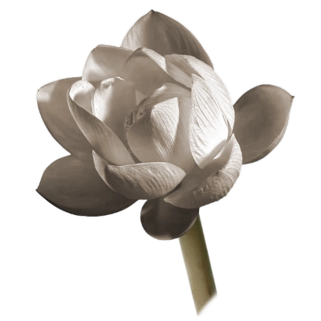

7. Insight

There are two conditions for the arising of right view:  
the words of another  
and attention to causes.

Mahāvedallasutta  
[MN 43:13.2–13.3](https://suttacentral.net/mn43/en/sujato#13.2)

Bare Attention

Now that our mind has become peaceful, we are ready for insight. So, let’s talk about what insight is, how important it is, how it works, and how it’s used.

Insight means seeing things clearly, but a lot of times people don’t see things clearly.

Let me tell you a story from one of my friends from Cambridge. His name is Bernard Carr, Emeritus Professor of Mathematics and Astronomy at Queen Mary University of London.

Some time ago at the Society for Psychical Research (SPR) at Cambridge University, one of Bernard’s colleagues announced that he’d discovered the secret of levitation. A demonstration was to be held in one of the lecture theatres at Imperial College London. Many professors were excited and decided to attend.

Bernard’s colleague brought in a flowerpot, holding it up and showing it to the audience. They could see that there were no strings, wires, or anything else attached to it. After putting it down on the table, he said, “You’re all experimental physicists with good reputations. You’re trained observers. I’m going to show you how to make this flowerpot levitate.” The audience looked at each other sceptically, but he continued, “Before we begin, I want you to help me create an atmosphere in this room. I want each one of you—never mind your religion or lack of religion—to please chant the holy word ‘Om’.”

With cameras ready to record the outcome, all the professors, lecturers, and researchers started chanting, “Om… Om… Om…” Suddenly, the flowerpot rose into the air! It worked! The cameras had caught it, providing clear evidence that the pot had lifted itself up.

After the pot came back down on the table, he asked them what they had seen. Many confirmed that the pot had indeed risen into the air, but some of those trained observers said the pot never rose at all.

The pot actually rose up, and the reason it did was that there was a huge electromagnet hidden under the table. The magnet required so much current that when it was switched on, a buzzing could be heard. He had asked the audience to chant “Om” to mask the buzzing sound and hide the trick!

Because they didn’t know it was a trick and because in their scientific view it simply couldn’t happen, their brain filtered out what had really occurred.

In fact, that was the whole purpose of the experiment: to show that even though something happens right in front of you, with all the supporting evidence to back it up, if it challenges your beliefs too much, you’ll wipe it out of your brain.

That’s one of the reasons I say that bare attention is not enough to get insight. Whatever you’re watching, whatever you’re feeling, or whatever you’re hearing, your brain always adds or subtracts from that.

What your mind brings to your attention is already filtered. That’s what the experiment had proven.

Distorters of Truth

So, how can you trust anything? You may experience a nimitta, but is it a real nimitta? Are you sure? Has your mind added anything to it or taken something away?

That’s always the problem with knowledge and truth. Why is it that there are so many highly intelligent human beings, and yet we can’t agree on what the truth is? It’s because what we see, hear, smell, taste, touch, and know is filtered.

This process of filtering is what the Buddha called the five hindrances: desire, ill-will, tiredness & lethargy, restlessness & remorse, and doubt. We think we are able to spot them, but are we?

Desire presents to you what you want to see. Ill-will hides the truth. There are some things that are so hard to accept that you bury the truth. This may happen, for instance, with past abuse. It’s so unpleasant to think about that you can’t even see it. Desire and ill-will present a distorted reality to you, but you think it’s the undistorted truth.

How many times does it happen in relationships that one partner says: “I can’t stand you. I’m leaving!”? It’s often a shock to the other partner because they didn’t see it coming. They may say, “Why didn’t you tell me what was bothering you? I could have done something about it.” The response might be, “I’ve been telling you for years!”

It’s not because the person is stubborn. It’s because the thought of separation is so distressing that they’re blind to the possibility. People bend the truth to fit what they want to see, and this is done largely subconsciously. The hindrances bend the truth. What you see is not real—it’s distorted.

That’s also the case when you’ve got tiredness and lethargy, which make the world seem dull and grey. You can’t see anything clearly because there’s no energy in the mind.

It’s the same with restlessness and worry. Your mind is wandering all over the place. You can’t stay still enough to see what’s truly there. I’ve said many times that when restlessness disappears and you’re still, it’s amazing how this world just opens up to you.

If I really open my eyes and look at the world, isn’t it suffering? Yes, it is, but there’s an incredible amount of beauty in it as well. In the ‘Auguries of Innocence’, William Blake said:

“To see a World in a Grain of Sand  
And a Heaven in a Wild Flower,  
Hold Infinity in the palm of your hand  
And Eternity in an hour”

1

When you see a world in a grain of sand, that's an insight practice. To see ‘a heaven in a wild flower’ is finding incredible joy in life, as if you’re holding ‘a whole infinity in the palm of your hand’. When you see ‘an eternity in an hour,’ you understand that time has no meaning anymore.

That is the kind of insight that people often don't expect. We can’t work it out through logic. Once you see it, you can justify it through logic by working backwards, but to get there without some experience of the mind opening up to clarity is rare.

The last hindrance is doubt. What is doubt? It’s hard to describe it. But a simile for doubt which works for me is being lost in the desert.

A guy has been lost in the desert for days and doesn’t know which way to go. He ran out of water long ago. Just as he is about to lose all hope, he sees something shimmering on the horizon.

“It’s just a mirage,” he thought, and didn't give it much attention. But then it came closer. This sounds crazy, but it appeared to be… a person on a sled, being pulled by husky dogs! “I really must be losing my mind,” he mumbled. Then, he heard the husky dogs barking.

The dog sled came right up to him, and a man in a large, white fur coat stepped out. The lost man rubbed his eyes, shook his head in disbelief, and said, “This can’t be true. I'm hallucinating.”

Just as he thought that, one of the dogs started licking him. The man in furs said, “Are you okay? Here, have some water,” and offered him a flask.

The man gulped down the water, some of it spilling onto his chin. When he’d had his fill, he shouted: “I was lost for days, but now you’ve found me! I'm saved!”

It was then that the Inuit said, “And you think you're lost!”

I can’t help telling jokes!

Now, back to doubt. How do you know how to meditate? Yeah, you can listen to me and say, “Ajahn Brahm’s a good meditator. He’s been doing this for such a long time, so it must be true.” But that doesn’t really count, does it?

The Vinaya,[18] the rules and regulations for Buddhist monastics, forbids us from talking directly about any amazing experience we’ve had. Still, I’ll tell you a story to show that you can recall your past experiences even though they happened a long time ago.

Once upon a time in a land not so far away, there was a meditation monk who lived in a forest. One day after coming out of deep meditation, he decided to do a little experiment. He asked himself, “What’s my earliest memory?”

Straight away, he experienced himself in a pram as a newborn baby. It wasn’t a memory in the same sense as you remember what you had for breakfast this morning; it was more like re-experiencing—he was back in his pram. He saw the black and white pram, and then he spotted his favourite toy, Porky! It was a blue ceramic pig that his mother had given him. It had beans inside that made a noise when he rattled it.

He could remember everything in that pram. He could also recognise his mother, not by how she looked but by how she smelled. At that particular time, as a little baby, he recognised his world by how it smelled.

As he was re-experiencing that early life memory, he had no doubt at all that it was him. The memory was clearer than seeing a piece of furniture in his meditation room. It was as if he were right there in the pram.

So, through deep meditation, one can recall an early life memory and even go back earlier to see past lives. The reason one can is that the five hindrances are gone. When the five hindrances are gone, you can see things clearly. You’re not deluded.

There’s one way to know the five hindrances are gone, and that’s through jhāna. When you emerge from them, one of the results is that the hindrances disappear for a while. The deeper the jhāna and the longer you experience it, the longer the hindrances remain absent. You find this stated in the Naḷakapānasutta ([MN 68](https://suttacentral.net/XXX/en/sujato#YYYhttps://suttacentral.net/XXX/en/sujato%23YYY)). That is one of the reasons nothing can upset you after a deep meditation.

It is not just the five hindrances that disappear, but two extra hindrances are also absent: aratī, ‘discontent’, and tandī, ‘weariness’.

With aratī absent, it’s like you’re walking on air. Because you’re so full of energy and positivity, sometimes you’ve got a stupid smile on your face. Nothing can upset you. If you’re old like me, you may feel weary when you get up in the morning, but after deep meditation, that weariness is gone. You have so much joy and energy that you get bubbly. This is what happens when the hindrances disappear.

The Tadpole and the Frog

The Buddha says that samādhi, otherwise known as jhāna, is the cause for seeing things as they really are.

In between jhāna and seeing things as they really are is a period of time when the five hindrances are gone. After you have entered and emerged from jhāna, the five hindrances aren’t there for quite a while, and so there’s nothing to distort your perception.

What you see now is real. What you see is true.

I call what we see in this way ‘real data’. With the mind free from the hindrances, you have an opportunity to see clearly and understand what it means.

There’s the simile of the tadpole and the frog. The tadpole is born in water and has lived all its life in water, and so it can’t understand water no matter how intelligent it is. Eventually, however, it grows arms and legs and becomes a frog. One day, that frog jumps out of the water onto dry land. It’s a weird experience. Something that has always been there—the water—is missing. Now the frog has a chance to gain insight into what water actually is.

In jhāna, something that’s always been there is missing. It’s not so much seeing what’s there as it’s seeing what’s missing.

One of the things to disappear in a jhāna is your five senses. Some people may argue, “I don’t experience my five senses when I go to sleep or when I’m under an anaesthetic. So, what’s the big deal?” The big difference is that in jhāna the mind is very aware. You have the full experience of what it’s like to just have the mind sense, the sixth sense, while the other five senses are now gone.

Once you jump out of the five-sense world, it’s a totally different experience. The experience of a deep state of meditation is so intense that you can never forget it.

One important thing to note is that while you’re in jhāna, you can’t do any contemplation because you’re too still. However, when you come out afterwards, you can look at the experience and start to understand exactly what it was, what was happening, and why it was happening. You see all of the details. That’s the raw and very rare data from which deep insight can come. You’re not seeing things in an ordinary way. You’re seeing things in a way which is very rare.

You’re now getting a deeper appreciation of anicca, impermanence. One of the standard explanations of this word, is that it means ‘rise and fall’. This is not the full picture. The full picture is that something which has always been there, though you may not even have noticed it, is now gone.

Have you ever seen darkness? Real darkness? I was nineteen years of age when I first experienced real darkness. One night I was walking home from a pub with my girlfriend. Living in London, there were always street lights, but not that night. We couldn’t see anything. I thought I knew what darkness was, but I only truly understood it the first time this thing called light had totally vanished. We often assume we know things, but we don’t know them until they’re not there anymore.

The disappearance of the five senses may be a strange experience, but it also tells you a bit about what happens when you die.

What is death anyway?

I’m not talking about dying. Dying can be unpleasant. Some people feel pain and struggle to stay alive. Death itself, when you go past a certain point, gives a sense of freedom. You don’t have these heavy five senses to worry about. Ahh, what freedom!

When you let go of the five senses, you are liberated. All your traumas from the past, your bad memories, and all your fears of the future are about five-sense stuff and have nothing to do with the mind. So, take away their importance and let them go. Imagine how free you’ll feel, with no worries about the five senses at all.

When you can do that fully, you’ll be an anāgāmī, a ‘non-returner’, never coming back to this world. It doesn’t make any sense for you to come back. No longer seeing any importance in the five senses, you’ll never come back to the five-sense world.

Do you see how insight works? Insight is experiential. You get nibbidā, or repulsion, towards the five senses. What is there to come back to?

If I gave you a choice, would you like to become a non-returner and never come back to this world, or would you like to have another round in the five-sense world? You might think, “Well, I got things wrong in this life, but now I’ve learnt my lesson. Now I know how to have healthy relationships.” So, you would want to come back.

A Prison Guard Named Will

Let me tell you the story of the man who was born in jail, grew up in jail, and lived his life in jail. He was a very good man who worked hard and had a good reputation, so they gave him a nice prison cell with a nice garden outside. He then found another nice prisoner, a woman, and they went to the jail dances and fell in love. They were given a nice big cell in the married section of the prison but had to work hard to pay off the mortgage on that cell.

Soon they had a couple of nice children. They looked after their children well and sent them to a prison school. Sometimes they would go on holiday to see another part of the prison. They were having a wonderful time.

They couldn’t always do what they wanted to, but that was okay because everyone else was the same. Compared to others, they thought that they were doing pretty well.

Then, one day a shaven-headed monastic visited the jail and said to them, “Don’t you realise that prison is suffering?” “It’s not suffering,” they countered, “You monastics are so negative!”

Seeing that they didn’t want to leave their prison, the monastic said, “Look, you can have a better life in jail if you learn how to meditate. You can get your work done more quickly and with higher quality. You won’t argue so much with each other, and you can be more peaceful with your kids, too.”

The two prisoners agreed to try. While they were meditating, it was as if they found a tunnel in their cell, a tunnel that led outside. They went through the tunnel and saw the world outside. For the first time in their lives, they realised what freedom was. It wasn’t theory; it was a real experience.

That experience changed their lives. They realised that all these years they’d actually been living in prison! The prison of the five senses.

The prison officer’s name was Will. Will tortured them by never allowing them a moment of peace. When they were trying to watch their breath, Will said, “No, don’t do it this way. Do it that way,” and “You should be doing something better than meditation. Volunteer. Have a cup of tea. Don’t just sit there; do something!” This Will fellow never allowed them to be peaceful.

That’s why when we’re meditating, we trick our will to be calm. Eventually the little prison officer falls asleep, which allows us to go into deep meditation. That’s what happens in the second jhāna.

In the second jhāna, something that has always been there is now missing. Something which people are so possessive of, the will, is gone. Will, choice, is no longer there. It’s just like in the simile of the tadpole. Now that the tadpole has turned into a frog and jumped onto land, he realises what is missing: water. He now knows what water is, what the will is.

It’s amazing when you understand what the will is, where it comes from, and how it disappears. It’s not that you decide not to exercise the will, but that the will has vanished. Freedom from will. That's the bliss of second jhāna.

It’s an unmissable, strong, and powerful experience. The only reason anyone who has such an experience doesn’t get an enlightenment insight is that they don’t know how to understand them. That is one of the reasons it’s important to have a teacher who does know and who can lead us on the path.

That’s why one of the two things you need in order to see the Dhamma is ‘parato ghoso’, the word of another enlightened being.

The Words of the Wise

Here is one of my favourite insight stories.

In his last years of life, before he had a stroke and couldn’t speak any more, Ajahn Chah was getting sick. We Western monks studied the Vinaya and discovered one thing that wasn’t well known in Thailand. In the time of the Buddha, the monks had saunas. So, we decided to build one for Ajahn Chah to help him keep healthy.

Another reason for building a sauna was that we then had an excuse to invite Ajahn Chah to visit Wat Pah Nanachat to give us a weekly talk. Wat Nanachat was the monastery where the Western monks were staying.

Usually when he came over, I’d listen to his talk and then go and help him take his sauna. However, one particular week, he gave a brilliant talk. It went right inside of me, and I started blissing out while listening to the Dhamma. Because there were enough monks to look after Ajahn Chah, I went to the back of the hall, sat down on the concrete, and meditated deeply for two hours. When I came out, I was really happy. I then wondered whether there was still time to help my teacher. I started walking towards the sauna but realised I was too late. Ajahn Chah was already coming along the path, heading towards the car that would take him back to his monastery, Wat Pah Pong.

Ajahn Chah walked towards me, looking me right in the eye as we approached one another. I could feel Ajahn Chah reading my mind. Often I’d be embarrassed, but at that moment I’d just come out of a very deep meditation, and for once, I was happy he was reading my mind.

He looked at me firmly. He then asked, fiercely and sharply, “Brahmavamso! Why?”

I paused. “I don’t know,” was all I could say.

Whenever we Western monks said something stupid like that, it’s amazing that these great monks would just laugh their head off. They thought it was so funny. People with all these big degrees from the West were so idiotic.

Ajahn Chah screwed up his face and said, “I’ll tell you the answer.” He had seen that my hindrances were gone for a while, and he wanted to see if he could enlighten one of his disciples.

“If anybody asks you the question ‘Why?’, the answer is, ‘There’s nothing.’” He paused, then asked, “Do you understand?”

“Yes,” I replied.

“No, you don’t,” he responded, and walked away.

It was a wonderful experience, even though I didn’t understand it at the time. Deep Dhamma takes a long time to penetrate.

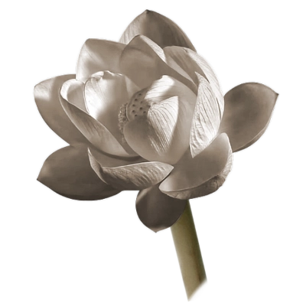

8. Step Back

When the heart’s release by love  
has been cultivated, developed, and practised…  
Your mind quickly enters samādhi.

Mettāsutta  
[AN 11.15](https://suttacentral.net/an11.15/en/sujato)

Stillness

In the last chapter we talked about big insight, but we actually use insight from the beginning of meditation all the way to the end. So, let’s step back a bit.

Many people find that even just being aware of the breath is difficult. Why? It doesn’t mean you’re not putting in enough effort. It means you’re putting in too much effort, so the mind can’t rest and be still.

The beginning of insight is to get good simple instructions, not unhelpful instructions. One of the unhelpful instructions is that samatha means ‘concentration’. Please delete that from your brain. Samatha means ‘stillness’. The very fact that you understand that the goal and meaning of meditation is stillness makes a big difference.

So, how can you be still?

First, you need to be aware of the causes of stillness. That’s insight into the causes of stillness.

Second, you need to know why stillness sometimes doesn’t happen. People laugh when I say that, but they don’t realise it’s deep. It’s an important part of meditation. People think meditation is about being fierce, and that if you want to get something, you’ve got to put everything into it. This is true, but in a different way from what you might think: putting everything into your meditation means relaxing to the max.

When you start meditating, are you relaxed? Do you know what ‘relaxed’ feels like?

Trust the Body

If you want a pleasant meditation, you've got to make sure everything in your body is good enough and that everything is settled. You relax it to the max so that the body won't disturb you. Then it's easy to have a nice time free of bodily problems. Sometimes we have some itches or aches in the body, though. It's okay. It’s natural.

To look after my body, I usually let my body look after itself. I ask my body how it feels and what it wants. That’s another way of being mindful: asking, not assuming.

If I want to find out how you are, I don’t just look at you and assume I know what’s going on with you. I ask you, “How are you feeling today?” When you ask with mindfulness, you might see something much deeper than the actual answer. Here is a story to show how this works.

The mother of a disciple of mine was comatose in hospital. Her doctor asked my disciple if they should turn off the machines and let her mother die. She asked me what she should do. I told her to go and stand next to her mother and ask, “Are you still there, Mum?”

A couple of days later she asked me to visit her mother. Sitting next to her mother’s bed, I made my mind peaceful and calm and listened to her mother. I told the disciple that her mother was so exhausted that she just wanted to die. That wasn’t psychic power; that was just being sensitive.

When I visited her once more a week or two later, I sat next to her bed again. This time I felt that her stream of consciousness had left her body, and that the machines were responsible for her body to carry on.

My point is: if you ask questions, you may get interesting answers. If that’s your mother or father in hospital and you want to know what you’re supposed to do, just be quiet, hold their hand, and ask the question, “Mum, are you still there?” Sometimes you’ll know if the body is just kept alive by life support or if your mother is still alive and might regain consciousness.

I do the same with my body. I trust I will understand my body when I’m mindful of it. I then get insight into how to be kind to it. If my body needs a rest, I give it a rest. With this sort of sensitivity, I rarely get sick. This is the beginning of insight: insight into having a calm and healthy body.

When you sit down, ask your body, “Body, do you want to meditate now?” Sometimes I ask my body and my mind, “What do you want to do? Do you want to sit down and have a glass of water? Do you want to go for a little stroll and explore some of the flowers in the monastery? What do you want to do?” I trust my body. When I listen carefully, I find that my body never wants to indulge and waste time doing stupid things. Instead, it often wants to do innovative things.

When you learn how to relax to the max, you’re a friend to your body. You get the insight that being a friend rather than a controller is the way to peace.

So, this gives insight into how to have a peaceful and healthy body. Even if you have chronic pain, rather than fight it, you can understand it and be kind to it. With all the unpleasant experiences in life, everything that comes up is a potential teacher to us. So, if there’s pain, try to learn something by giving it kind attention. If you open the door of your heart to it, it’s amazing what you can learn. These insights aren’t ordinary insights. You get useful information about your body and how to look after it, which means you learn how to relax the body to the max.

The Buddha said that we should start our meditation with kāyagatāsati, mindfulness of the body. When we watch our body first, it prepares the mind for meditation. Some people may say no; they just want to get straight to the nimitta. They want the fast-track meditation. But when you follow the Buddha’s advice, you realise that his advice is the real fast track.

Waiting in the Present

I’ve done lots of building work in my life as a Buddhist monk. The most important part of building is the preparation, to make sure you’ve got really good foundations. Before you paint, you prepare the wall by removing the grease until it’s clean. If you’re making a garden, most of the work isn’t planting the seeds but preparing the soil. The preparation is always important. The same applies to meditation.

You may hear monastics say that meditation is really easy—all you need to do is go into the nimitta. Just watch your lotus with loving-kindness and mindfulness, and the lotus will open. It sounds easy, doesn’t it? But the most important part is the preparation: making sure you have strong mindfulness and kindness. This will enable you to focus on the lotus and not interfere when it starts opening up.

Ajahn Chah told this story when I first came to train under him as a young monk. It was an extended simile of Wat Pah Pong being like a mango orchard, with the mango trees planted by the Buddha himself. Now all these mango trees were mature and full of ripe, juicy mangoes. Still, if you were to throw a stick at them, none would fall down. If you were to shake the tree, they would not go anywhere. Even if you were to climb the tree, you would not be able to reach those mangoes. There was only one way, Ajahn Chah said, to get any of those sweet, delicious mangoes: to sit perfectly still underneath the tree and hold out a hand. Then, a mango would eventually fall.

I was a trained scientist, and to me, this story was irrational. I know that many people like to believe that the Buddha went to this and that country, but I’m pretty sure he never went to Wat Pah Pong. Even if he had, he wouldn’t have planted mango trees. And mangoes falling into your hand? Totally illogical. So, I forgot about it. Or so I thought.

A wonderful thing about the Dhamma is that a teaching which may sound silly when we first hear it or may appear far away from where we are currently at may get stored away in a little corner of our mind. We don’t realise it’s stored there until, one day, we get close to deep meditation experience. Just when we need it, the information comes up. Something clicks and we remember.

It’s like the seeds in the Australian desert that stay dormant for years. Then one day a rainstorm comes, and all those seeds sprout and come to fruition.

The only way to get those beautiful fruits of the practice is to stop trying to get anything. Stop trying to make anything happen. Just sit perfectly still. It’s easy once you’ve stopped trying, but to achieve the stopping can be hard.

We’re so addicted to trying. Many of us don’t even know what it’s like not to do anything. You may get frustrated because even though you’ve tried so hard, nothing’s happening in your meditation. At such times we should remember to relax to the max and open our heart with kindfulness. You can then be still and at peace with whatever happens.

That’s when the mangoes fall.

The Donkey and the Carrot

To understand this better, I’ve developed a simile for how this happens. It’s the story of the donkey and the carrot.

The donkey is one of the most stubborn animals in the world. A farmer may hit their donkey with a stick to try to get it to move, but the donkey often just endures. So, instead of punishing the donkey, give it positive encouragement. Tie a stick to the donkey’s neck so that the end of the stick is a few feet out in front of the donkey. At the end of the stick, hang a carrot from a string.

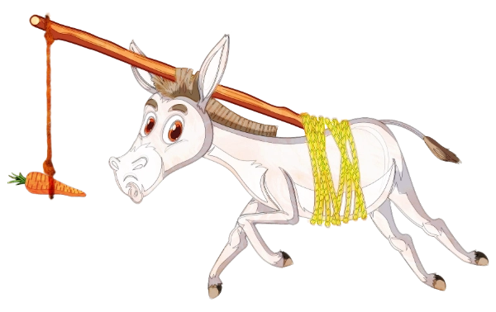

When the donkey sees the carrot dangling just ahead of its mouth, what does it do? Because donkeys like carrots, it moves towards the carrot, but as it moves, so does the carrot. The more the donkey moves forward, the more the carrot moves too. The carrot is always a few feet out in front of the donkey. The donkey can see and smell the carrot and can almost taste it, but it can never reach it.

Does this story have any similarity to your life? Happiness, success, deep meditation, or whatever else you want in life is always a little bit out of reach, isn’t it? You’ve been running after nimittas, jhānas, and insights, but have you got them yet?

So, how does the donkey catch the carrot?

If the donkey has been paying attention, it would know how to catch the carrot. It’s the easiest thing in the world.

It just has to stop.

The carrot has been moving along with you as you chase it. But when you stop, because of the forward momentum, it will actually move farther away from you. Likewise, when you relax to the max in meditation, you may think nothing’s happening. In fact, you may even think the mind is getting worse!

The carrot swings away and then pauses when it reaches the farthest point on the arc. Then, it slowly starts swinging back towards you, speeding up towards its original position, and now coming to you at top speed. You’ve been chasing it, and now it’s chasing you!

It’s just the same with the breath. Remember, I’ve told you not to go looking for the breath, but to wait for the breath to come to you? Like the donkey, you wait until the breath is swinging towards you. Of course, it’s more than the breath—it’s the nimitta, jhāna, and everything.

img/DonkeyGotCarrot.webp= =40=borderless

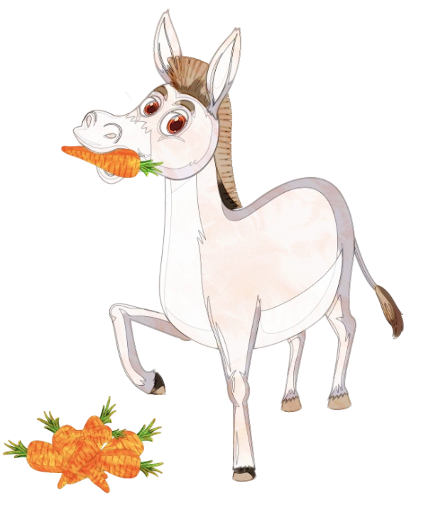

The last instruction to remember is to sit perfectly still under the mango tree and wait in the present with your hand of kindfulness open. Compassion is a crucial part of this.

That's how many people get their first deep meditation experience. They go chasing it, but when they stop and let go, a beautiful meditation experience happens.

The Nāḷāgiri Strategy

Some people may know how to stop, but they don’t know how to stop long enough. They’re really relaxing and a nice nimitta comes up, but then they try to do something with it, like developing it or going inside it. That was a problem for me too. You need to keep on kindfully ‘relaxing to the max’ all the way. Only then can you get into some really nice and deep meditation.

Another issue comes up when you’re peacefully watching the breath and the breath starts to disappear: no ‘oomph’ in the meditation. It’s just flat. I call this a pause or a blockage. At this point, it is best not to put forth any effort because that will mess things up. It’s as if you came across a brick wall in your meditation and keep banging your head against it, thinking you can break through. That’s a silly response. It’s not going to work.

Instead, I imagine standing back a bit to gain some perspective. Then, I see that to the left there’s an open door that I can just walk through. To the right, there’s a ladder that I can use to climb over. Standing back even further, I see that the government couldn’t afford to finish building the wall. To the right and left there is no wall at all!

I’m not sure about you, but the biggest hindrance I had was ill will, to which kindness is the best antidote. So, whenever I was blocked anywhere, I’d always remember having kindness to the whole process. “You don’t have to get enlightened today, Ajahn Brahm. You don’t have to do anything.” I’d shine that kindness all over. Once you see the obstacle, give it kindness and the obstacle will vanish. I call this technique the Nāḷāgiri strategy.

When Devadatta[19] was trying to take over the Saṅgha,[20] King Ajātasattu helped Devadatta by lending him a huge elephant called Nāḷāgiri.[21] They got Nāḷāgiri mad with strong drink and let him loose down a street where the Buddha and his monks were coming on alms round. The elephant ran down the narrow street, smashing everything in its path. In the opposite direction, the Buddha was walking calmly and mindfully.

According to the story, many of the monks who were with the Buddha jumped into the houses along the side of the street. Only Ānanda,[22] the Buddha’s faithful disciple, remained with the Buddha. With this huge, powerful, and destructive monster of an elephant running at full speed towards them, Ānanda stood in front of the Buddha and said, “Let the elephant take me. I’ll give my life for my teacher.” But the Buddha told Ānanda to stand aside.

With his psychic powers, the Buddha could easily have grabbed Nāḷāgiri by the trunk and thrown him over the Ganges River a couple of hundred miles away, but that’s not what he did. Instead, the Buddha gave this drunken, mad elephant loving-kindness. And Nāḷāgiri stopped and bowed down to the Buddha.

Kindness was what subdued the mad elephant. So, when you have an attack of any of the hindrances, no matter what hindrance it is, no matter how strong it is, employ the Nāḷāgiri strategy: “Hindrances, the door of my heart is open to you.” When you use kindness as an antidote, the hindrances won’t be able to harm you.

One of the insights you gain from meditation is how powerful loving-kindness is. You get insight into how to be kind to your body and your mind when you're meditating. Also, you understand that it's a beautiful way of living.

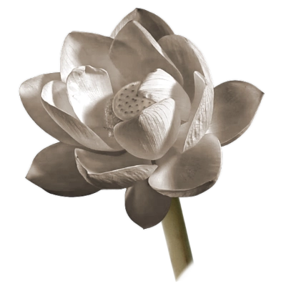

9. Into The Heart

No jhāna for one without wisdom,  
No wisdom for one without jhāna.  
But one with both jhāna and wisdom—  
They are in the presence of nibbāna.

Dhammapada  
[Dhp 372](https://suttacentral.net/dhp372/en/sujato)

When (I thought) I was enlightened

We’ve talked about insight, but what about the big insights? What are we doing all this for? Let me tell you the story of when I became enlightened.

It was my fourth rains retreat, so I’d already been meditating a while. I was staying at a very peaceful monastery in the north-east of Thailand with very little work to do. I was senior enough to know the basics, but not senior enough to have any responsibility. It was a wonderful time.

One evening the bright moon lit up the forest, making it easy to do walking meditation under the trees. I’d already had some nice sitting meditation, and my practice was going really well. I had lots of energy and clarity. As I continued the walking meditation, great insights started to come. When we have a proper insight, we see things in a totally different way, which in turn gives rise to so much joy and energy. So, even though it was late at night, I didn’t want to sleep. I enjoyed these different ways of looking at the world.

It was then that the big one came. “Wow! Amazing!” I was now seeing the world in a totally new way. Straight away I thought the world had another arahant.[23] Oh, that was so lovely! Can you imagine what it is like to become enlightened? Nothing left to worry about in the whole world. Perfect peace and happiness!

After walking some more, I went to the hall to sit. At one o’clock in the morning I’d always be a bit sleepy, but now my body was straight and my mind absolutely clear. Watching my breath was as easy as pie.

At about two o’clock, I thought I should have a rest because all the monks were scheduled to meet at three. So, I went to my hut and lay down, but there was no way I could sleep with so much energy and joy. I got up again and went back to the hall to meditate. When the other monks came for the morning chanting, I chanted with so much energy and joy, my pitch perfect, my voice strong and clear.

Afterwards, when we went on alms round, it was like walking on air. Because we are not normally supposed to talk to our supporters on alms round, I just blasted them with loving-kindness. They didn’t know how lucky they were to give rice to an arahant!

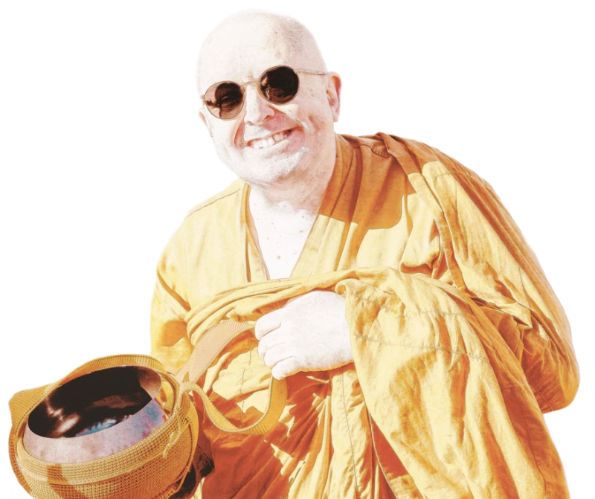

For our one meal of the day, we’d usually have one pot of curry to go with the rice. It was normally rotten fish curry.[24] The curry might have some banana shoots or whatever else they could find. It really stank.

That morning, we had a usual pot of rotten fish curry, but next to it was another pot. It was a very rare treat of lovely pork curry! “Ah… the heavenly beings must be celebrating a newly enlightened monk in the world,” I thought.

In our practice, when food was offered, the head monk would have first choice. The head monk took one big ladleful of the pork curry and put it in his bowl, and then another one, and another! Three huge servings! “You can’t eat all that!” I found myself thinking, but then I thought, “Oh, it doesn’t matter. There’s plenty left for me.”

Just as I was thinking that, he lifted up the lovely pork curry pot and poured it into the stinky, rotten fish curry, stirred it all up, and said, “It’s all the same. It’s all the same.”

“If it’s all the same, why did you take it first?! You should have mixed it up beforehand!” I was fuming. The first decent meal in a month, and it was all wasted.

It was then that I realised enlightened beings don’t get upset!

You don’t really know what depression and disappointment is until you think you’re enlightened and find out you’re not! That was a bad day for me.

I’m telling you that story to show how we can deceive ourselves.

Big Insight

Let’s go back to the simile of the thousand-petalled lotus. One of the things I like about this simile is that it shows you how the whole path works. For instance, the inner petals of the lotus, the jhānas, only open up through the simple qualities of kindness, mindfulness, and patience.

Now, there are two types of patience. The first kind is waiting for something to happen in the future. The second kind is waiting in the present. Please practise the second kind of patience.

While sitting in meditation, open yourself up more and go deeper inside the delightful breath. You don’t have to go and get it from somewhere, or to go and make it happen. The beautiful breath is hidden inside all the other layers of lotus petals.

Jhāna is even deeper within. To uncover it, you need to open even more petals and see what’s inside. As the petals open up, what’s inside the first jhāna is the second jhāna, and inside the second jhāna is the third jhāna. When the third jhāna opens up, the fourth jhāna is right there inside it. Beautiful, gorgeous contentment.

By that time, the petals are so thin that they’re like gossamer—you can almost see through to the next layer of petals. They’re very refined, out of this world with their beauty and fragrance, and they give so much joy.

Many of you may know that in the Vajrayāna tradition, there is a chant that goes “Om mani padme hum.” Om is like namo, meaning “homage to”, and hum is like sādhu, meaning “well said” or “excellent”. Both express reverence to mani, which means jewel, and padme, which means lotus. This chant is to worship the jewel in the heart of the lotus. That is ‘you’.

As you open yourself up, after those last layers of petals open, you can see the jewel in the heart of the lotus, at the centre of you. Do you know what that jewel is?

It is ‘nothing’.

The Driverless Bus

There’s the simile of the driverless bus that can further explain this.

Your life is like a bus journey. As you’re riding in your bus, you look through the window and there’s rolling green hills, lovely trees, and waterfalls. So, you ask your bus driver, “Can you slow down? I want to take in the scenery.” And what does your bus driver do? He puts his foot on the accelerator and speeds up.

Sometimes you go through the toxic waste dumps of life. You tell the driver to put his foot down and get out of there quickly, but what does he do? He slams on the brakes and slows down.

Why is it that the unpleasant, difficult, awful times of life last much longer than they should?

Maybe you can teach the driver to do what you want. But to be able to teach them, you’ve got to locate the driver first of all. So, you get out of your seat and walk to the front of the bus, but when you get there, you find the bus driver’s seat is empty!

What happens next? You walk back to your seat and stop complaining. There’s no one to complain to. There’s no bus driver. So, how can you tell the bus driver what to do? When you see that the bus driver’s seat is empty, desire and ill-will make no sense.

The driver of your life, what you think of as choice and will, is just nothing. The bus driver’s seat can be seen in the second jhāna. That’s when you find that there’s no one there.

That’s what you see deep inside the lotus.

Emptiness—that’s the jewel.

Let me say more about this issue of the will or the doer. One of the most meaningful experiments I saw as a student at Cambridge University was an event organised by the Society for Psychical Research. They had all sorts of unusual people come to give talks, including a hypnotist. And because we were young students, he had no problem finding volunteers.

Some people can be hypnotised easily, and some can’t, but there is always someone who is a great subject. Once the hypnotist had hypnotised a suggestive student, he told him, “After I take you out of hypnosis, I’m going to touch my left earlobe. When I do, you’ll stand up and sing the British national anthem.”

When the hypnotist had finished making this student do all sorts of embarrassing things, he took him out of hypnosis and sent him to sit down. During the next twenty minutes, being a great entertainer, every now and then, he’d pretend to move his finger to his ear, but then he would scratch his nose instead! He did this again and again until he had us all on the edge of our seats.

Finally, he touched his ear, and this poor student stood up and sang “God Save the Queen” at the top of his lungs! He sang the whole national anthem, even as we were wetting ourselves with laughter. When he finished, the hypnotist asked him, “Why did you do that?” The young man gave what, to him, was an apparently excellent reason.

That’s when I got chills down my spine. That student was convinced he’d freely chosen to sing, but it was obvious to us that he’d just made up the reason. He sang because the hypnotist told him to.

How many times, while thinking we were making free choices, were the choices really free? How many times were we conditioned to make them?

This is one of the reasons I don’t mind spending a lot of time and effort teaching you. I’m brainwashing you, in a good way. That’s what the Buddha did. The Buddha Kassapa[25] did that to our Buddha. The Buddha did that to his disciples, like Ānanda and Sāriputta,[26] and they did that to their disciples. Eventually, the teachings were passed down to Ajahn Chah’s teacher, Ajahn Mun. Ajahn Chah then did it to me, and now, I’m doing it to you. It’s good brainwashing because it’s how we learn to let go.

So, we rely on the words of another, parato ghoso. It is one of the most important conditions to become a stream-winner,[27] to see non-self, and to see that there’s no doer in there.

Stages of Disappearing

When you go deep into that lotus, deep into meditation, you can see that this idea of a self is conditioned. It’s not an absolute eternal entity. It’s empty. There is nothing there.

Sometimes people find that hard to accept because of their attachment to the sense of self. People want to be things—they want to be the doer or the knower—because that gives them an identity. But the more spiritually advanced you are, the less you have of a sense of self.

The jhānas are stages of disappearing where there’s less and less of the sense of you. When there’s less you, there’s less of a target for suffering. There’s more peace and more happiness. You’re not weighed down by anything.

Success or failure, praise or blame—none of this means anything. Even the Buddha received a lot of blame. He said there’s no human being in this world who only receives praise and never blame. It’s not about what you do; it’s largely about the defilements of others.

As you keep on practising letting go, you own less and less. Eventually, you become possession-less. You don’t attach to anything, which means that the whole idea of attainments disappears. You understand that the path of freedom is a path of having less.

If somebody asks you, “Are you enlightened?” you say, “Who?” Is Venerable Khemā sitting here enlightened? Who is Venerable Khemā? Is it her body that gets enlightened? The vedanā? The saññā? The saṅkhārā?[28] When you put it like that, it shows you how meaningless it is to think of these as attainments. Or again, which of your six senses is enlightened?

Thinking that ‘you’ are enlightened shows you that you’re not.

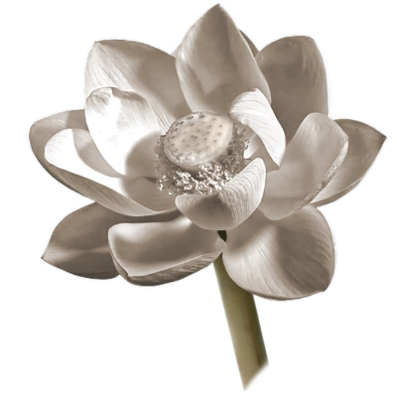

10. Let The End Come

My mind became serene,  
like a fine thoroughbred steed.  
Then, taking a lamp,  
I entered my dwelling…  
I drew out the wick.  
The liberation of my heart  
was like the quenching of the lamp.

Paṭācārā  
[Thig 5.10](https://suttacentral.net/thig5.10/en/sujato)

Break from the Herd

This chapter is about how to apply what you’ve learnt to your everyday life.

In your work, maybe you’ve been disappointed that your boss promoted somebody else instead of you. I’ve given so many talks in Singapore, and people there are really keen on being promoted. I ask them, “What happens if you get promoted?”

People want to be promoted to have more status and more money, but actually they’ll have more worries and less time. Yes, you get an increase in salary, but it’s never enough, and you have to work harder. Is it worth it?

Wouldn’t it be better not to get promoted? You won’t get as much money, but if you know how to live simply, you’ll have less stress in your life as you don’t have the extra pressure. In many places I visit, I hear people complain that they don’t have enough time for themselves or their loved ones, let alone for meditation retreats. They’re wealthy in terms of money in the bank, but they don’t have enough time to pursue the real wealth of happiness.

Wouldn’t it be wonderful if people did what they wanted to do, such as go on meditation retreats, rather than what they have to do because of their career?

There’s an old saying that’s inspired me all my life: “When everybody thinks the same, no one thinks at all.” If you think the same as everybody else, then you’re not thinking, and you’re not really gaining any insight. Because it’s easier in the sense that no one will criticise you, you’re just following the same path as everyone else.

If you go on a meditation retreat, some people may criticise you for it. “You say you’ve been meditating? What are you doing that for? Life is short. Enjoy it! There are so many beautiful places to visit.”

We believe what other people say, so some places become tourist attractions simply because other people think they’re beautiful. But what is beauty? I like the idea of being a little bit rebellious and seeing for yourself what is beautiful, seeing for yourself what is worthwhile. How do you want to live your life? What’s important to you? You don’t have to follow what other people say and do.

That degree of confidence will make your life much more interesting. You’re not just following old beaten paths, even in your contemplation of the Dhamma.

When I talked about ānāpānassati, I didn’t get to the last stages of the Ānāpānassatisutta. Some people translate this part as contemplating impermanence, fading away, cessation, and giving up. Are you thinking about that after you come out of a jhāna? You can’t. You’re just far too still.

So, what is contemplation? I prefer the idea of exploring. Take ‘anicca,’ something that was there is now gone. You hold the idea in front of you and let the mind explore it. Not in words, nor in ideas. You just give the mind the freedom to explore:

“What is this?”

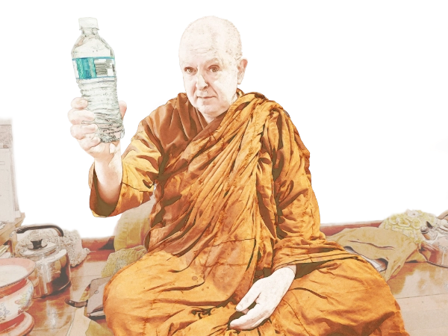

You look at a water bottle and find out it’s far more than a water bottle. Some of the things in life are far more than you’ve been told or taught they are. When you really explore that water bottle, you find all sorts of different ways of seeing it and making use of it, and that makes life fascinating.

There was a movie many years ago called ‘The Gods Must Be Crazy’. A pilot flying over the Kalahari Desert threw a Coca-Cola glass bottle out the window. An African tribesman who lived a very simple life discovered it and brought it back to his village. As he’d never seen such a thing before and had no idea what it was for, he used it in all sorts of interesting ways. His wife would use it as a rolling pin, and sometimes to hit him on the head! That was not a very good use. Nonetheless, this story shows an example of somebody who’d never been taught certain things and so was able to see things in a totally different way.

With stillness, not thinking, you’ll be able to get insight by allowing your mind to explore the Dhamma. It’s almost like you let the thing you’re exploring teach you, rather than trying to find out what it means.

With meditation, you don’t do anything. Let the breath come to you. With insights, you don’t go seeking. Let the wisdom come to you.

Stop Trying

I haven’t yet properly discussed the topic of trying too hard. You may think you are not, but you are. There’s the famous story of Ānanda’s enlightenment, which demonstrates how trying too hard isn’t going to get you anywhere.

After the Buddha had passed away, the Saṅgha decided to hold a meeting to collect his teachings.[29] Even though Ānanda wasn’t fully enlightened, they wanted him to be part of it because he had heard and remembered so many of the Buddha’s teachings.

Imagine how Ānanda, who was only a stream-winner, must have felt when he got invited to join the meeting with four hundred and ninety-nine fully enlightened arahants!

The night before the big meeting, in an effort to make the final breakthrough, Ānanda meditated all night. When dawn arrived, he was still unenlightened. There are certain things that you just can’t rush or force with willpower.

It was depressing to know that in a few hours he’d have to face his friends and colleagues, all fully enlightened, except for him. He couldn’t do anything about it now. He’d tried his very best. There was still some time left before the meeting, so he decided to take a nap. He went to his room, and as he lay down, just before his head hit the pillow, he became enlightened!

So, if you’ve tried all other ways to become enlightened and nothing has worked, try the Ānanda method!

Ānanda got enlightened because he stopped trying to attain anything. He completely let go. He wasn’t a donkey chasing a carrot anymore. He stopped, and the carrot came to him.

Trust the Mind

When you have a problem in meditation, it’s usually because either you’re trying too hard, or you fall asleep when you let go. For instance, you may get a nimitta, but then start working on it, trying to hold it. Or the nimitta may make you excited or afraid. If you get excited, desire arises. If you get afraid, you attempt to stop it. Either will ruin the whole meditation, and you go back to square one. So, how can we solve this problem?

One of the things you can do is to program your mindfulness. You do this at the very beginning of the meditation. You sit down comfortably and tell yourself three times: “If a nimitta comes up, I won’t get excited.” Listen to what you’re saying with as much mindfulness as you can and then discard it. Don’t try to remember it. It’s already been programmed into you to be used at the right time. It’s amazing how that works. When you’re having a good meditation and a nimitta comes up, you’d normally get excited. But this time, sub-verbally, the mind remembers, “No excitement,” and you get past that hindrance.

You can also use this method for other purposes, like when you want to meditate for an hour but have to come out for an appointment, as I have already mentioned in an earlier chapter. When you start meditating, say to yourself three times, slowly, carefully, and meaningfully: “I must come out of meditation by eleven o’clock.” Make sure to specify a.m., because you don’t want to come out of meditation an hour before midnight!

Sometimes when there was a problem in my meditation, an amazing solution would just arrive. Where did that insight come from? When I traced it back, I often found that it was something Ajahn Chah had told me years ago! It was stored somewhere in my mind, ready to come up when it was really needed.

That’s why we teach like this.

So, please, at the end of the retreat, don’t think: “Ajahn Brahm, you always talk about nimittas and jhāna, but I couldn’t even watch a single breath. My best practice was half a breath!”

Don’t mind that because these teachings have been programmed into you. At the right time and the right place, they will come to fruition, and then it will all work. When that happens, you can ask yourself: “Where did that come from?” It’s either myself or some other good teacher. Now you understand it for yourself. Having put the teaching into practice, you see how it works.

The End

To finish, let’s come back to the topic of big insights, one of which is Dependent Origination. Let’s look at it through the lens of a story.

At the time of the Buddha, there was a wonderful woman who got fully enlightened and became one of the best teachers of that time. Her name was Paṭācārā.

Paṭācārā was the only daughter of a wealthy family in Sāvatthī. She fell in love with one of her household servants, and going against the wishes of her parents, she ran away with her lover.

They went to live in a faraway village, and in time she had a son. Yet, despite her husband’s objections, she longed to visit her family in Sāvatthī. One day, unable to resist any longer, and even while heavily pregnant with her second child, she set out for Sāvatthī, taking her son with her.

On realising what she’d done, her husband followed her and caught up with her on the way, pleading for her to return, but she refused. Just as she had given birth on the road, a storm blew up, and she asked her husband to prepare a shelter. While her husband was out in the rain gathering materials for a roof, he was bitten by a snake and died. In the morning, Paṭācārā found him dead. Stricken with grief, she continued towards her parents’ home with her two sons.

When she came to the river Aciravatī, it was flooded because of the heavy rain the night before. The current was so strong that she was unable to carry both her sons across at once. She then crossed with the newborn first, deposited him on the far shore, and returned for the young boy. Just as she was returning, a hawk swooped down and snatched the baby.

Crying out, she rushed back to the shore to try to save her baby. Her elder son, waiting on the other side of the river, heard his mother’s voice and thought she was calling him. He slipped down the riverbank, was swept away by the current, and drowned.

With so much pain, she still managed to carry on towards Sāvatthī. On the road, she saw a man and asked him about her family. He told her that her parents’ house had collapsed the previous night, killing her parents and her brothers.

And so, within twenty-four hours, she had lost her husband, children, parents, and siblings. The grief was too much for Paṭācārā, and her mind snapped. She cast off her clothes and stumbled around, naked and senseless, through the streets of Sāvatthī. In her aimless wandering, she came to the Jetavana monastery, where the Buddha happened to be staying. With his words of kindness, she regained her senses and covered herself up. The Buddha then gave her a teaching, at the end of which she became a stream-winner.

She joined the order of bhikkhunīs[30] and practised well. One night after meditation, she was watching the flame in her oil lamp. Just then, a gust of wind blew in through her window, causing the flame to flicker and then to go out. She understood the meaning of what she saw: anicca. That was the end of all her other defilements.

When you see the cause of something, you also understand that when the cause disappears, so does the result. That’s what dependent cessation is. The cause of our mind consciousness is nāmarūpa, the objects of consciousness. When the objects of mind consciousness stop, our consciousness ceases.

When this happens, our consciousness is not just in a dormant or suspended state, like a TV screen when the program comes to an end. No. When the program stops, the TV itself vanishes. When there’s nothing on the screen, the screen disappears too.

That is a quick glimpse of dependent cessation.[31]

5

…Spend time with a true person,   
intelligent and learned.  
Having understood the meaning and  
putting it into practice,  
one who understands the teaching   
will find happiness.

Nāvāsutta   
[Snp 2.8:8.1–8.4](https://suttacentral.net/snp2.8/en/sujato#8.1)

Notes

Abbreviations

|  |  |
| --- | --- |
| AN | Aṅguttara Nikāya |
| Dhp | Dhammapada |
| DN | Dīgha Nikāya |
| Iti | Itivuttaka |
| Ja | Jātaka |
| KN | Khuddaka Nikāya |
| Kp | Khuddakapāṭha |
| Kv | Kathāvatthu |
| MN | Majjhima Nikāya |
| Snp | Suttanipāta |
| Sutta | Sutta Piṭaka |
| Thag | Theragāthā |
| Thig | Therīgāthā |
| Ud | Udāna |

All references are to the Buddhist scriptures called the Pāḷi Tipiṭaka, or the Three Baskets of the Pāḷi Canon. See [suttacentral.net/pali-tipitaka](http://suttacentral.net/pali-tipitaka)  
  
References are to the numbering scheme used in the English translations published by SuttaCentral ([suttacentral.net](https://suttacentral.net/?lang=en))

People, Places & Treatise

Ajahn Chah

Phra Bodhiñāṇathera was a highly respected Buddhist monk in Thailand, and Ajahn Brahm’s teacher. He was instrumental in establishing Theravada Buddhism in the West.

Ajahn Mun

a famous Thai Buddhist meditation monk. Along with his mentor, Ajahn Sao Kantasīlo, he established the Thai Forest Tradition, with emphasis on meditation, that subsequently spread throughout Thailand and abroad.

Ānanda

the Buddha's cousin and attendant, renowned for his zealous devotion and for memorising the teachings.

Bodhinyana Monastery

a Buddhist forest monastery in the Darling Range, near the small town of Serpentine, Western Australia. Home to Ajahn Brahm and his Saṅgha.

Brahmavaṁso

Ajahn Brahm’s full monastic name. ‘Brahmavaṁso’ means lineage of Brahma.

Buddha Kassapa

one of the previous Buddhas mentioned in the Pali Canon. The word ‘Buddha’, meaning the Enlightened One, is usually applied to Buddha Gotama, the founder of Buddhism of today.

Devadatta

a monk, a close relative of the Buddha, who split the Saṅgha and attempted to overthrow the Buddha and have him murdered.

Māra

generally regarded as the personification of Death, the Evil One, the Tempter.

Paṭisambhidāmagga

The Paṭisambhidāmagga or “Path of Analytical Discernment” is an advanced critical treatise in thirty chapters on Buddhist practice, which the Pali commentaries attribute to the Buddha’s disciple Sāriputta. This text introduces a number of terms and ideas of great importance in later Buddhist philosophy.

Sāriputta

the Buddha’s disciple foremost in wisdom.

Three questions by Leo Tolstoy

Taken from the collection:   
‘What Men Live By, and Other Tales’ by Leo Tolstoy,   
as translated by Louise Maude and Aylmer Maude.   
This work is in the public domain.

0

It once occurred to a certain king, that if he always knew the right time to begin everything; if he knew who were the right people to listen to, and whom to avoid; and, above all, if he always knew what was the most important thing to do, he would never fail in anything he might undertake.

And this thought having occurred to him, he had it proclaimed throughout his kingdom that he would give a great reward to anyone who would teach him what was the right time for every action, and who were the most necessary people, and how he might know what was the most important thing to do.

And learned men came to the King, but they all answered his questions differently.

In reply to the first question, some said that to know the right time for every action, one must draw up in advance a table of days, months and years, and must live strictly according to it. Only thus, said they, could everything be done at its proper time. Others declared that it was impossible to decide beforehand the right time for every action; but that, not letting oneself be absorbed in idle pastimes, one should always attend to all that was going on, and then do what was most needful. Others, again, said that however attentive the King might be to what was going on, it was impossible for one man to decide correctly the right time for every action, but that he should have a Council of wise men, who would help him to fix the proper time for everything.

But then again others said there were some things which could not wait to be laid before a Council, but about which one had at once to decide whether to undertake them or not. But in order to decide that, one must know beforehand what was going to happen. It is only magicians who know that; and, therefore, in order to know the right time for every action, one must consult magicians.

Equally various were the answers to the second question. Some said, the people the King most needed were his councillors; others, the priests; others, the doctors; while some said the warriors were the most necessary.

To the third question, as to what was the most important occupation: some replied that the most important thing in the world was science. Others said it was skill in warfare; and others, again, that it was religious worship.

All the answers being different, the King agreed with none of them, and gave the reward to none. But still wishing to find the right answers to his questions, he decided to consult a hermit, widely renowned for his wisdom.

The hermit lived in a wood which he never quitted, and he received none but common folk. So the King put on simple clothes, and before reaching the hermit’s cell dismounted from his horse, and, leaving his body-guard behind, went on alone.

When the King approached, the hermit was digging the ground in front of his hut. Seeing the King, he greeted him and went on digging. The hermit was frail and weak, and each time he stuck his spade into the ground and turned a little earth, he breathed heavily.

The King went up to him and said: “I have come to you, wise hermit, to ask you to answer three questions: How can I learn to do the right thing at the right time? Who are the people I most need, and to whom should I, therefore, pay more attention than to the rest? And, what affairs are the most important, and need my first attention?”

The hermit listened to the King, but answered nothing. He just spat on his hand and recommenced digging.

“You are tired,” said the King, “let me take the spade and work awhile for you.”

“Thanks!” said the hermit, and, giving the spade to the King, he sat down on the ground.

When he had dug two beds, the King stopped and repeated his questions. The hermit again gave no answer, but rose, stretched out his hand for the spade, and said:

“Now rest awhile-and let me work a bit.”

But the King did not give him the spade, and continued to dig. One hour passed, and another. The sun began to sink behind the trees, and the King at last stuck the spade into the ground, and said:

“I came to you, wise man, for an answer to my questions. If you can give me none, tell me so, and I will return home.”

“Here comes someone running,” said the hermit, “let us see who it is.”

The King turned round, and saw a bearded man come running out of the wood. The man held his hands pressed against his stomach, and blood was flowing from under them. When he reached the King, he fell fainting on the ground moaning feebly. The King and the hermit unfastened the man’s clothing. There was a large wound in his stomach. The King washed it as best he could, and bandaged it with his handkerchief and with a towel the hermit had. But the blood would not stop flowing, and the King again and again removed the bandage soaked with warm blood, and washed and re-bandaged the wound. When at last the blood ceased flowing, the man revived and asked for something to drink. The King brought fresh water and gave it to him. Meanwhile the sun had set, and it had become cool. So the King, with the hermit’s help, carried the wounded man into the hut and laid him on the bed. Lying on the bed the man closed his eyes and was quiet; but the King was so tired with his walk and with the work he had done, that he crouched down on the threshold, and also fell asleep—so soundly that he slept all through the short summer night. When he awoke in the morning, it was long before he could remember where he was, or who was the strange bearded man lying on the bed and gazing intently at him with shining eyes.

“Forgive me!” said the bearded man in a weak voice, when he saw that the King was awake and was looking at him.

“I do not know you, and have nothing to forgive you for,” said the King.

“You do not know me, but I know you. I am that enemy of yours who swore to revenge himself on you, because you executed his brother and seized his property. I knew you had gone alone to see the hermit, and I resolved to kill you on your way back. But the day passed and you did not return. So I came out from my ambush to find you, and I came upon your bodyguard, and they recognized me, and wounded me. I escaped from them, but should have bled to death had you not dressed my wound. I wished to kill you, and you have saved my life. Now, if I live, and if you wish it, I will serve you as your most faithful slave, and will bid my sons do the same. Forgive me!”

The King was very glad to have made peace with his enemy so easily, and to have gained him for a friend, and he not only forgave him, but said he would send his servants and his own physician to attend him and promised to restore his property.

Having taken leave of the wounded man, the King went out into the porch and looked around for the hermit. Before going away he wished once more to beg an answer to the questions he had put. The hermit was outside, on his knees, sowing seeds in the beds that had been dug the day before.

The King approached him, and said:

“For the last time, I pray you to answer my questions, wise man.

“You have already been answered!” said the hermit, still crouching on his thin legs, and looking up at the King, who stood before him.

“How answered? What do you mean?” asked the King.

“Do you not see,” replied the hermit. “If you had not pitied my weakness yesterday, and had not dug those beds for me, but had gone your way, that man would have attacked you, and you would have repented of not having stayed with me. So the most important time was when you were digging the beds; and I was the most important man; and to do me good was your most important business. Afterwards when that man ran to us, the most important time was when you were attending to him, for if you had not bound up his wounds he would have died without having made peace with you. So he was the most important man, and what you did for him was your most important business. Remember then: there is only one time that is important—Now! It is the most important time because it is the only time when we have any power. The most necessary man is he with whom you are, for no man knows whether he will ever have dealings with any one else: and the most important affair is, to do him good, because for that purpose alone was man sent into this life!”

The letting loose of Nāḷāgiri

This is a translation of [Kd 17:3.11.1–3.13.4](https://suttacentral.net/pli-tv-kd17/en/brahmali#3.11.1)  
by Bhikkhu Brahmali,  
and sourced from SuttaCentral

0

At that time in Rājagaha there was a fierce and man-killing elephant called Nāḷāgiri. Just then Devadatta entered Rājagaha, went to the elephant stables, and said to the elephant keepers, “We who are relatives of the king are capable of having people promoted and getting them a raise. So then, when the ascetic Gotama comes walking along this street, release the elephant Nāḷāgiri down it.”

“Yes, sir.”

Then, one morning, the Buddha robed up, took his bowl and robe, and entered Rājagaha for alms together with a number of monks. And the Buddha walked down that very street. When the elephant keepers saw the Buddha coming, they released Nāḷāgiri down the same street. Nāḷāgiri saw the Buddha coming. He blew his trunk, and with ears and tail bristling, he charged toward the Buddha. When the monks saw Nāḷāgiri coming, they said to the Buddha, “This elephant coming down the street is the fierce, man-killer Nāḷāgiri. Please retreat, venerable sir.”

“Come, don’t be afraid. It’s impossible for anyone to kill the Buddha through an act of violence. The Buddha won’t attain final extinguishment through an act of violence.”

A second time and a third time those monks said the same thing to the Buddha, each time getting the same reply.

On that occasion people had ascended their stilt houses and even their roofs. The foolish people with little faith and confidence said, “The elephant will hurt the handsome, great ascetic.” But the wise people with faith and confidence said, “Soon the great man and the great elephant will meet in battle.”

The Buddha then pervaded Nāḷāgiri with a mind of love. Feeling it, Nāḷāgiri lowered his trunk, went up to the Buddha, and stood in front of him. And while stroking Nāḷāgiri on the forehead with his right hand, the Buddha spoke these verses:

“Do not, elephant, attack a great man;  
Painful it is to attack a great man.  
For a killer of a great man,  
The next birth is not good.  
  
Don’t be intoxicated or heedless,  
For the heedless are not happily reborn.  
Only do those things  
That take you to a good destination.”

Nāḷāgiri sucked the dust from the Buddha’s feet with his trunk and scattered it overhead. He then walked backward while looking at the Buddha, and returned to his stall in the elephant stables. That is how tame Nāḷāgiri had become. On that occasion people chanted this verse:

“Some are tamed with sticks,  
And some with goads and whips.  
Without stick or sword,  
The great sage tamed the elephant.”

And people complained and criticized Devadatta, “How evil and indiscriminate he is, this Devadatta, in trying to kill the ascetic Gotama so powerful and mighty!” Devadatta’s material support and honour declined, whereas those of the Buddha increased.

Glossary

Pāli Terms

Arahant

awakened being. One who has gained insight into the true nature of existence.

Arūpasamāpatti

‘formless’ or ‘immaterial’ attainments

Bhikkhunī

a fully ordained Buddhist nun, a female mendicant.

Dhamma

here it refers to the teachings of the Buddha. In Buddhism, Dhamma is the doctrine, the universal truth common to all individuals at all times, proclaimed by the Buddha. The Dhamma, the Buddha, and the Saṅgha (community of Buddhist monastics) make up the Tiratana, the Three Jewels or the Triple Gems, to which Buddhists go for refuge. In Buddhist metaphysics the term in the plural (dhammas) is used to describe the interrelated elements that make up the empirical world.

Ekaggatā

unification or oneness of mind.

Kamma

here it refers to actions of moral significance which result in consequences in this life or future lives.

Mettā

benevolence, loving-kindness, or friendliness. The cultivation of mettā is a form of Buddhist meditation.

Nimitta

a mental perception appearing before the entry to jhāna.

Samādhi

perfect peace of mind, stability of mind, stillness of mind.

Saṅgha

the Buddhist monastic order of monks and nuns.

Saṅkhāra

there are several sides of the application of this word. Here it refers to mental formation, one of the five aggregates.

Saññā

sense, perception. One of the five aggregates.

Suttas

the scriptures and discourses of the Buddha.

Vedanā

feeling, sensation. One of the five aggregates.

Vinaya

code of ethics, monastic discipline, rule, rules of morality or of canon law. In this sense it is applied to the large collection of rules of the Buddhist Canon.

English Terms

Enlightenment

a translation of the Pāli word Nibbāna, meaning the sense of well-being, ease, and happiness, experienced through the knowledge of the freedom from suffering in oneself.

Rotten fish curry

a curry with fermented freshwater fish. The fermented fish, ‘pla ra’, has a very strong, distinctive smell.

Stream-winner

the first stage of enlightenment (also known as stream-enterer). There are four stages of awakening in Early Buddhism and Theravada, Sotāpanna (stream-winner), Sakadāgāmi (once-returner), Anāgāmi (non-returner), and Arahant (awakened being).

Author Biography

**Ajahn Brahmavamso Mahathera**, known to most as **Ajahn Brahm**, was born Peter Betts in London, United Kingdom on 7 August 1951. In the late 1960s, he received a scholarship to study Theoretical Physics at Cambridge University, where he first met other Buddhists and joined a Buddhist group. A few weeks after the age of 18, he saw a monk for the first time, and he knew then that was what he wanted to be.

After graduating from Cambridge, he taught at a high school in the UK for a year before travelling to Thailand to become a monk. He was ordained as a monk by Somdet Buddhajahn at Wat Saket in Bangkok, Thailand, on 5 December 1974. In January 1975, Ajahn Brahm travelled to Ubon Ratchathani in the northeast of Thailand to become a student of meditation master Ajahn Chah at Wat Nong Pah Pong. He later became a founding saṅgha member of Wat Pa Nanachat, an international monastery not far from Wat Nong Pah Pong. This new monastery was established by Ajahn Chah to cater for the increasing number of Westerners who were coming to ordain and train with him.

Ajahn Brahm was the Vinaya (code of monastic discipline) master at Wat Pah Nanachat from 1975 until his departure in 1983. His Vinaya notes are still authoritative for most Western Buddhist monks in the Theravada tradition. In 1983, Ajahn Chah asked Ajahn Brahm to go to Perth to assist Ajahn Jagaro in teaching duties supported by the Buddhist Society of Western Australia (BSWA). Later that year, BSWA purchased a rural forested property south of Perth to build Bodhinyana Monastery, the first and largest Buddhist monastery in the Southern Hemisphere. In 1995, upon the departure of Ajahn Jagaro, Ajahn Brahm became the Abbot of Bodhinyana Monastery.

In October 2004, Ajahn Brahm was awarded the John Curtin Medal for his vision, leadership and service to the Australian community. In June 2006, the King of Thailand conferred upon Ajahn Brahm the title of Phra Visuddhisamvarathera, the rank of Phra Raja Khana in the ordinary class (Vipassanā or meditation category).

In October 2009, he was instrumental in facilitating Bhikkhuni ordinations at his monastery. Apart from empowering women in Buddhism, Ajahn Brahm is also a supporter of LGBTQI+ rights.

In September 2019, Ajahn Brahm was appointed a Member of the Order of Australia, General Division Medal, for significant services to Buddhism and to gender equality.

Ajahn Brahm is currently the Abbot of Bodhinyana Monastery, the Spiritual Director of the Buddhist Society of Western Australia, Spiritual Adviser to the Buddhist Societies of Victoria and South Australia, and Spiritual Patron of the Buddhist Fellowship in Singapore.

Ajahn Brahm has authored several books, including Opening the Door of Your Heart, Happiness Through Meditation, The Art of Disappearing, and Bear Awareness. His Dhamma talks are downloaded millions of times a year.

1. See the Notes section at the end of this book for the full text.
2. Ajahn Chah was Ajahn Brahm’s teacher.
3. Jhana Grove is the name of the BSWA Meditation Centre near Perth.
4. Samādhi is the stillness of mind in deep meditation.
5. In this context, nimitta means the perception of bright light that normally appears before jhāna.
6. Brahmavaṁso is Ajahn Brahm’s full monastic name.
7. Ajahn Mun was a famous Thai Buddhist meditation monk.
8. Enlightenment means freedom from suffering. Nibbāna in Pāli.
9. The teaching of the Buddha is known as Dharma, which is spelt Dhamma in Pāli.
10. The Suttas are the Buddha’s discourses.
11. Māra is the Evil One or the Tempter.
12. Kamma or karma means deed. ‘Unfortunate kamma’ here was used to mean ‘bad luck’.
13. Mettā is loving-kindness or friendliness.
14. Bodhinyana Monastery is a Buddhist forest monastery in Western Australia and the home Ajahn Brahm.
15. The Paṭisambhidāmagga, known in English as the Path of Analytical Discernment, is part of the Khuddaka Nikāya, the fifth and last collection of discourses in the Theravada Canon.
16. For instance, in the Dhammacakkappavattanasutta at [SN 56.11](https://suttacentral.net/XXX/en/sujato#YYY).
17. Ekaggatā means unification or oneness of mind.
18. The Vinaya is the monastic law for fully ordained Buddhist monks and nuns
19. Devadatta was a monk who split the Saṅgha and attempted to kill the Buddha.
20. The term “Saṅgha” refers to the Buddhist monastic community of monks and nuns.
21. See the Notes section at the back of this book for the full text.
22. Ānanda was the Buddha's cousin and attendant
23. An arahant is a fully enlightened or awakened being
24. ‘Rotten fish curry’ is what Ajahn Brahm called a north-east curry made with fermented freshwater fish.
25. Buddha Kassapa was one of the previous Buddhas mentioned in the Pali Canon.
26. Sāriputta was one of the Buddha’s chief disciples and foremost in wisdom.
27. Stream-winner is the first stage of enlightenment.
28. Vedanā means feeling, sensation, saññā means perception, saṅkhāra means willed activities.
29. The story of the first communal recitation, or Council, is given in the Chapter on the Group of Five Hundred, Pañcasatikakkhandhaka of the Vinaya Piṭaka, at Kd 21
30. A bhikkhunī is a fully ordained Buddhist nun
31. For more on Dependent Cessation see the booklet *Dependent Liberation* by Ajahn Brahmali [wiswo.org/books/dlbl](https://wiswo.org/books/dlbl)